

SRI LANKA INSTITUTE OF INFORMATION TECHNOLOGY

[**Enterprise Standards and Best Practices for IT Infrastructure**](http://courseweb.sliit.lk/course/view.php?id=137)

**4th Year 2nd Semester 2016**

Name: Reyhart D.S.A

SLIIT ID: IT13064082

Practical Session: WE Monday

Practical Number: Lab 1,2,3

Date of Submission: 30-07-2016

Date of Evaluation : _____________________

Evaluators Signature : _____________________

**Lab 01**

Getting started with Amazon Windows instance

1. Login to Amazon Web Services.

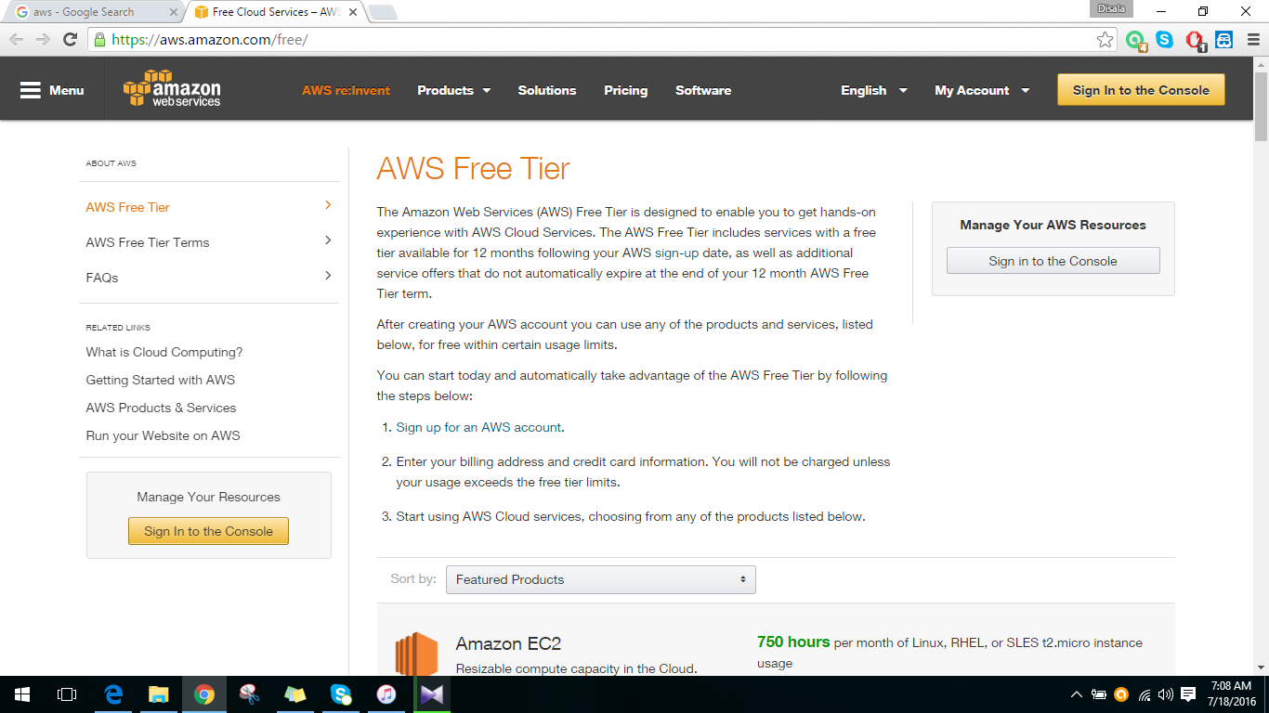

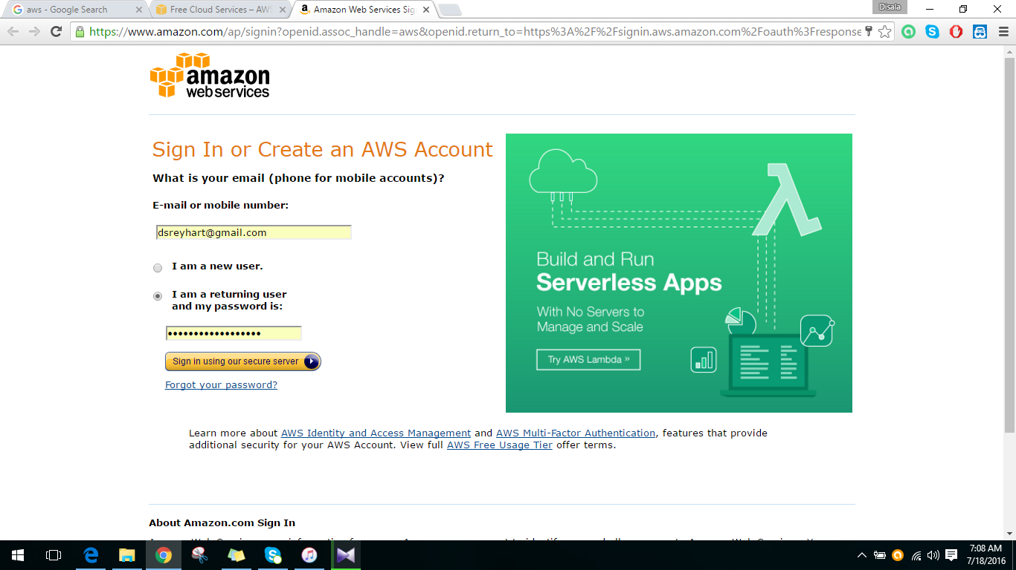

2. Create EC2 instance in Amazon Web Services.

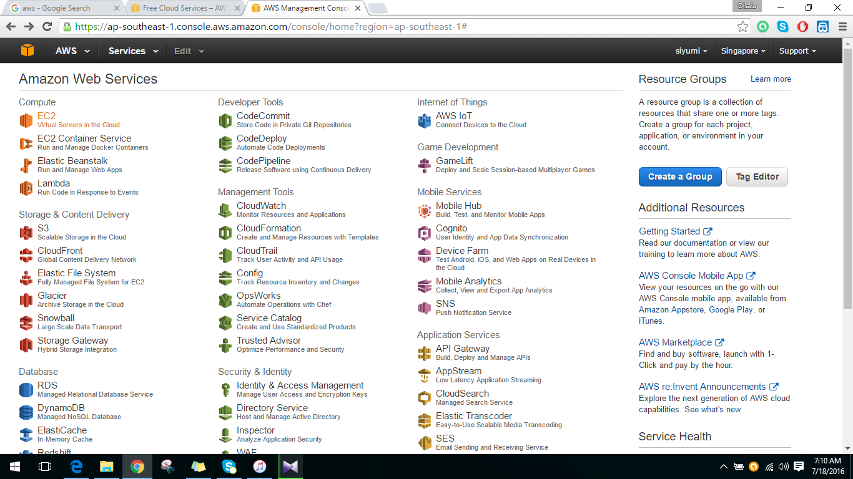

3. Launch EC2 instance

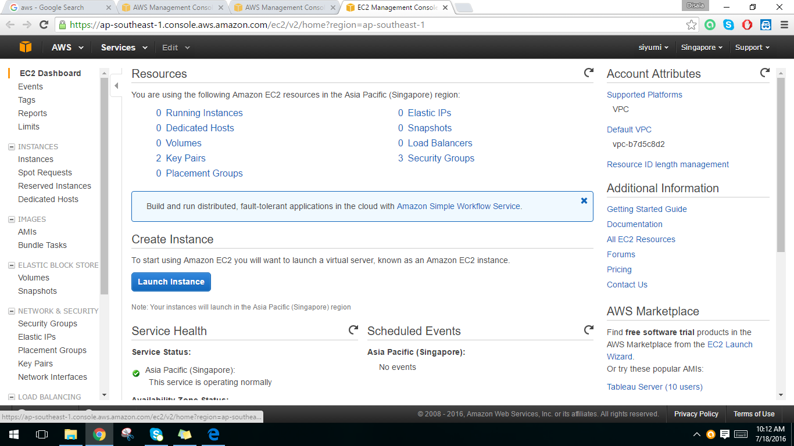

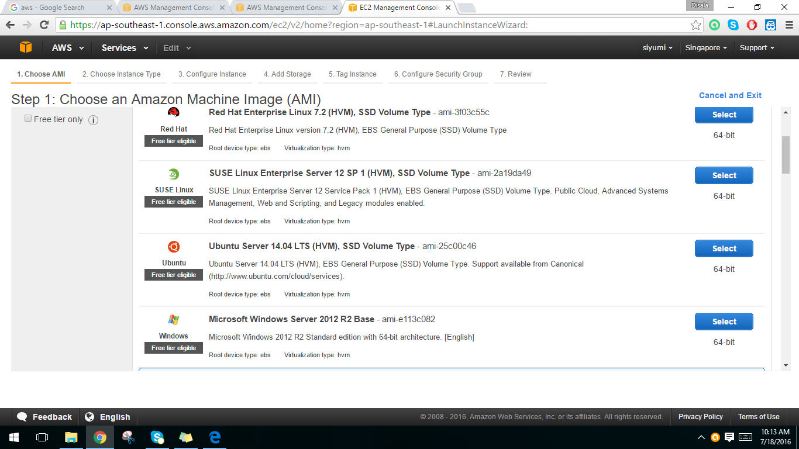4. Select Microsoft Windows Server 2012 R2 Base

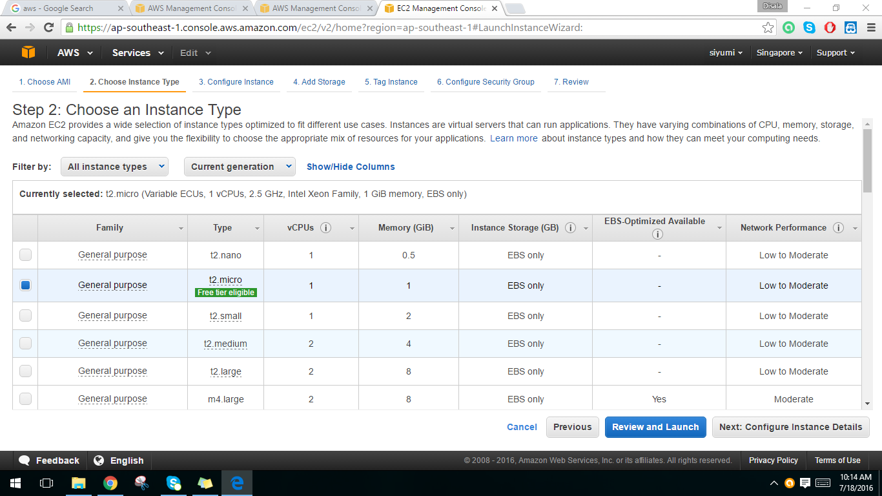5. Choose t2.micro as the instance type. Then click on configure instance details button.

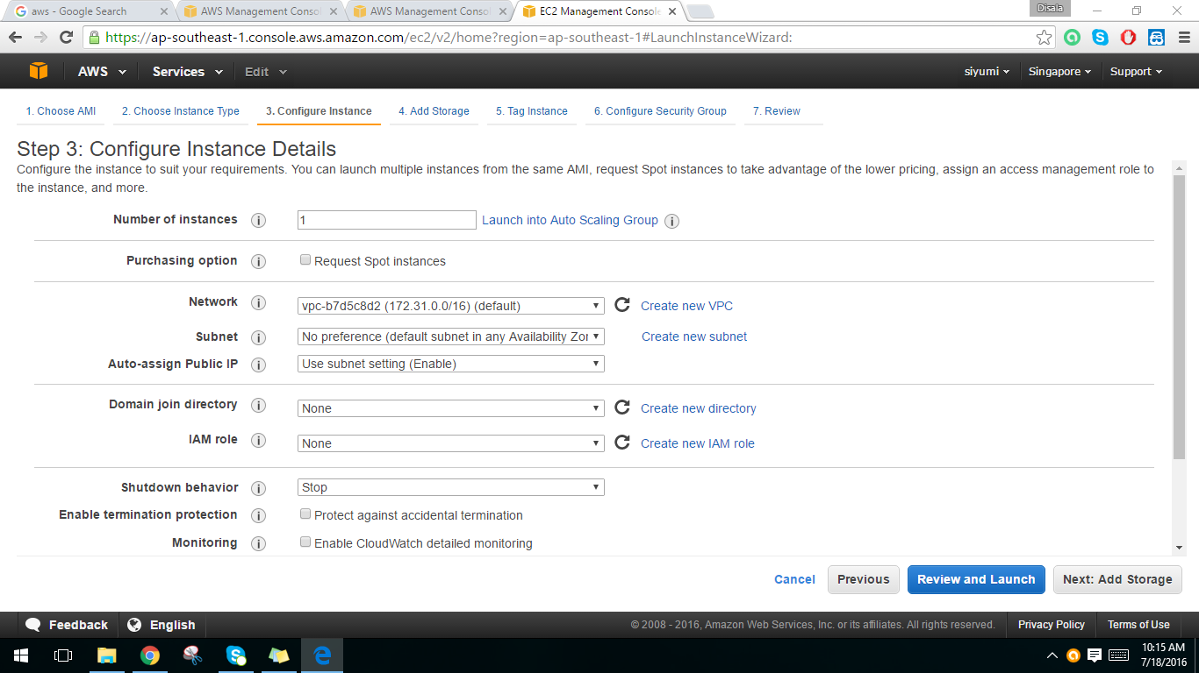6. Configure instance details. Click next to add storage.

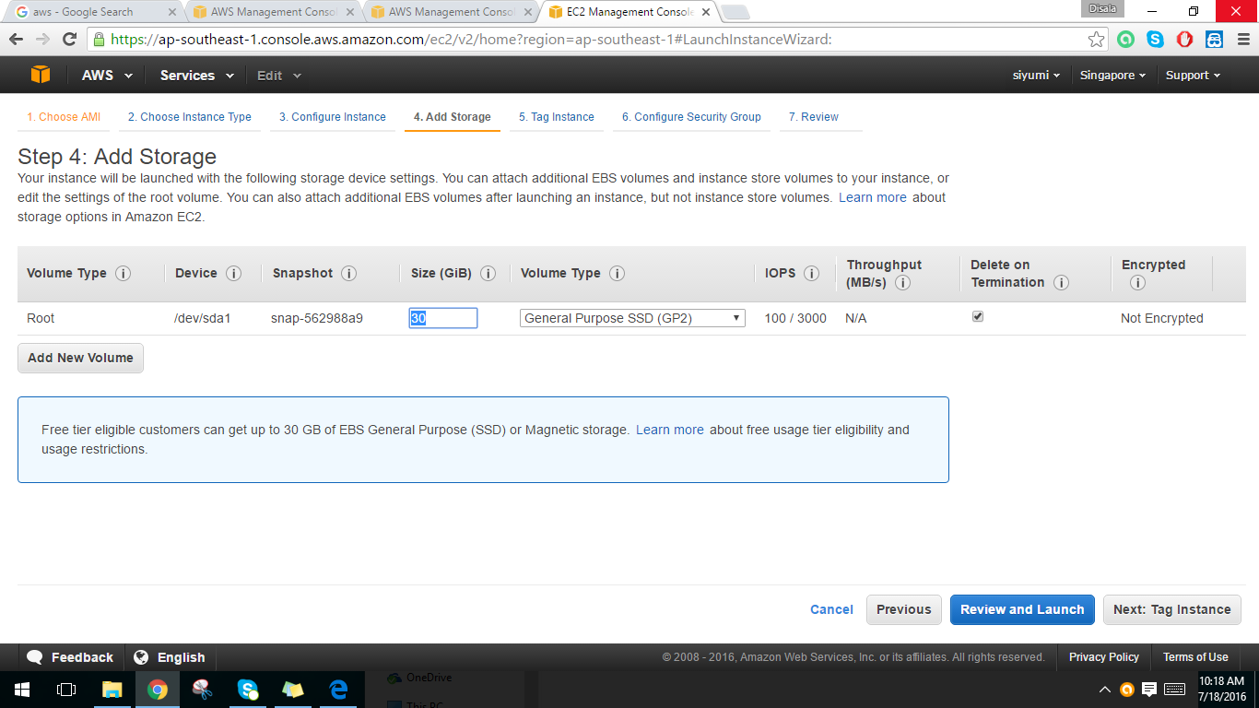7. Keep the storage size as 30 GiB. Then click Tag Instance button.

8. Tag instance. Click on Review and Launch button.

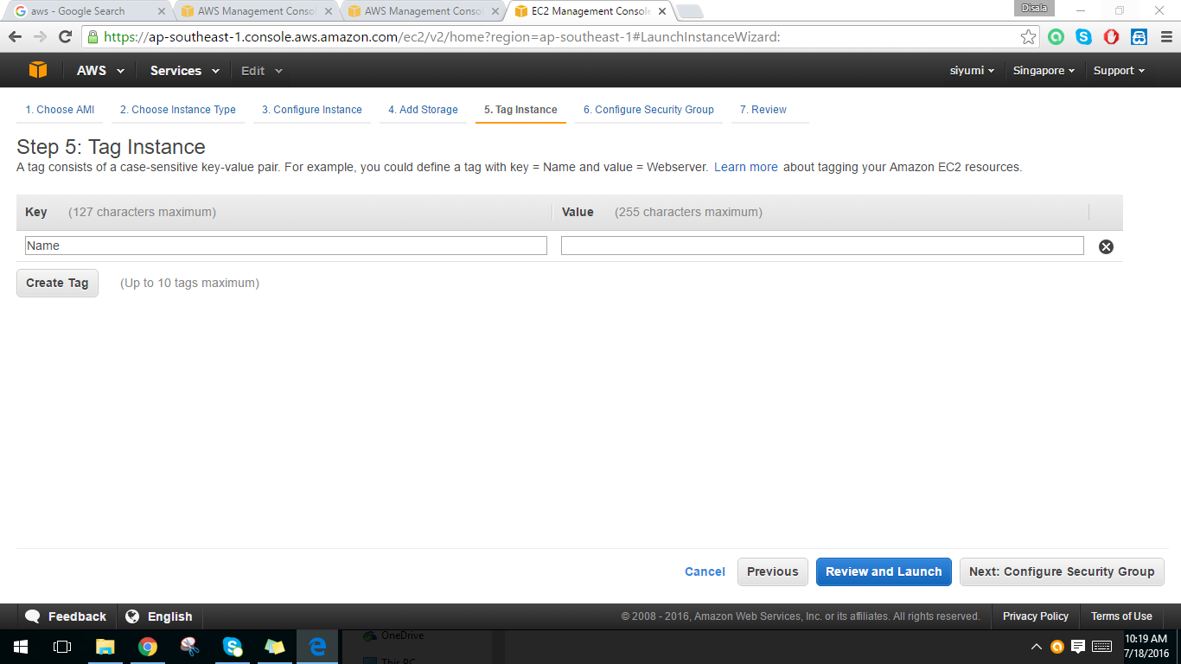

9. Review instance launch. Click on launch button.

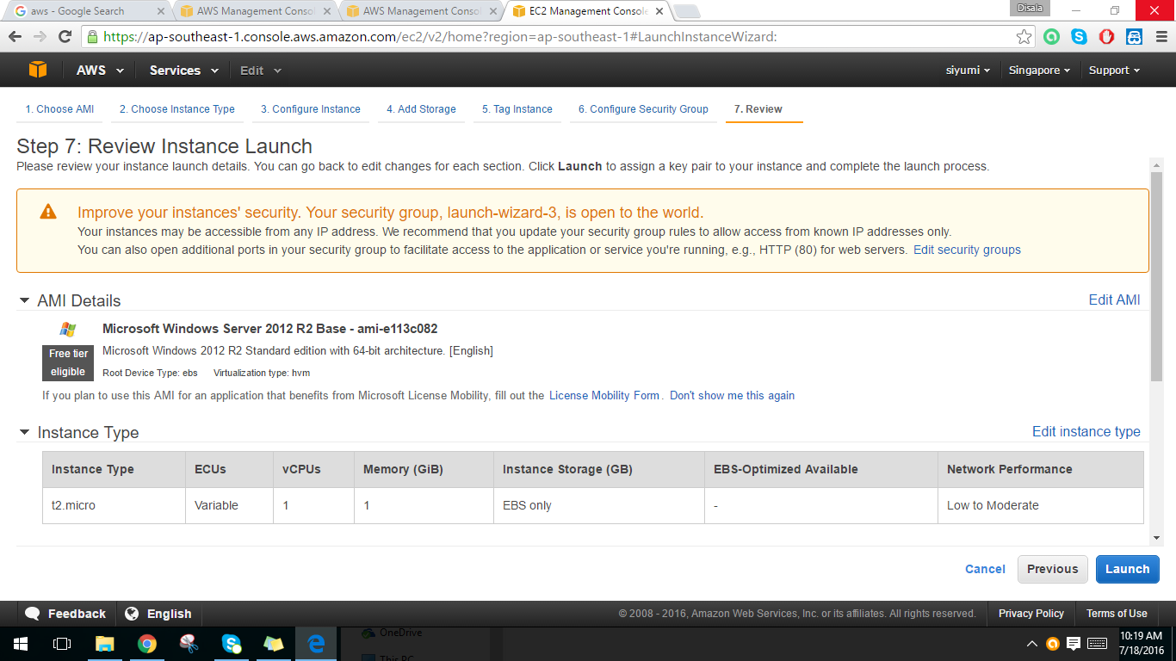

10. Create a new key pair for security issues and download the key pair.

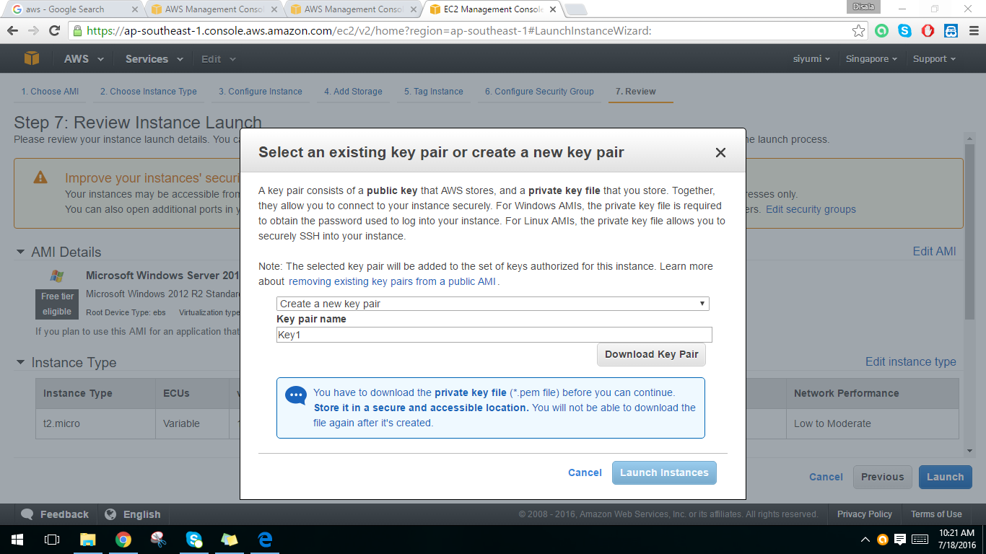

11. Status of the launch.

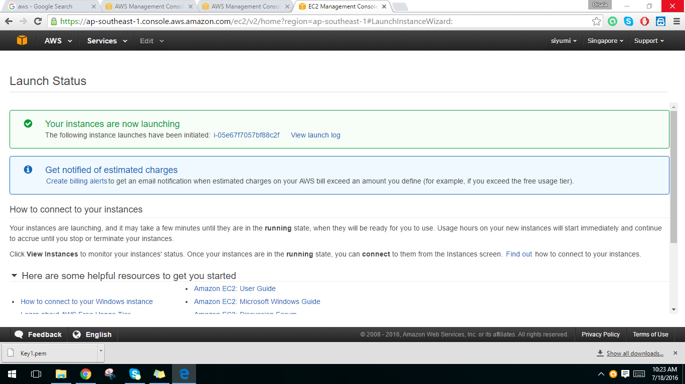

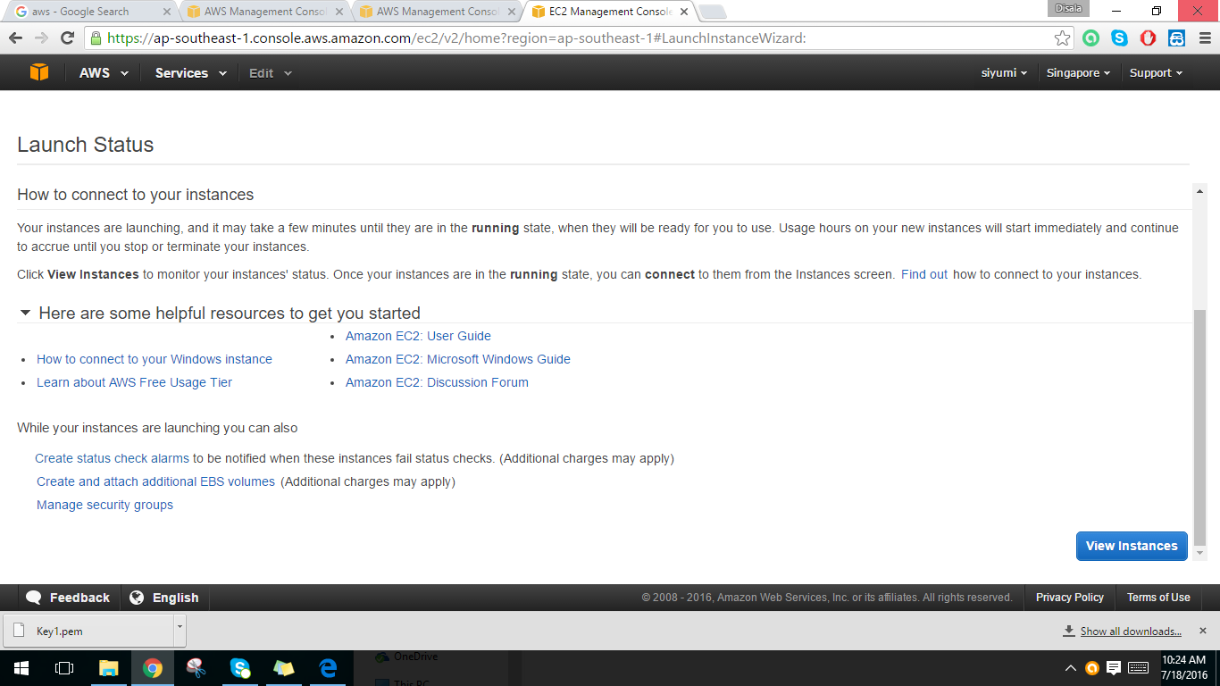12. Click on view instance button.

13 To connect to a Windows instance click the created instance and click connect.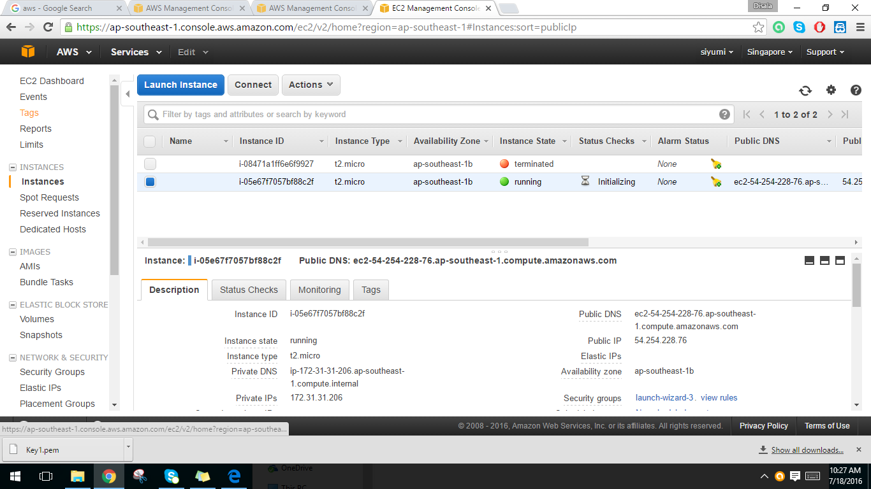

14. To connect should give the password. So click get password.

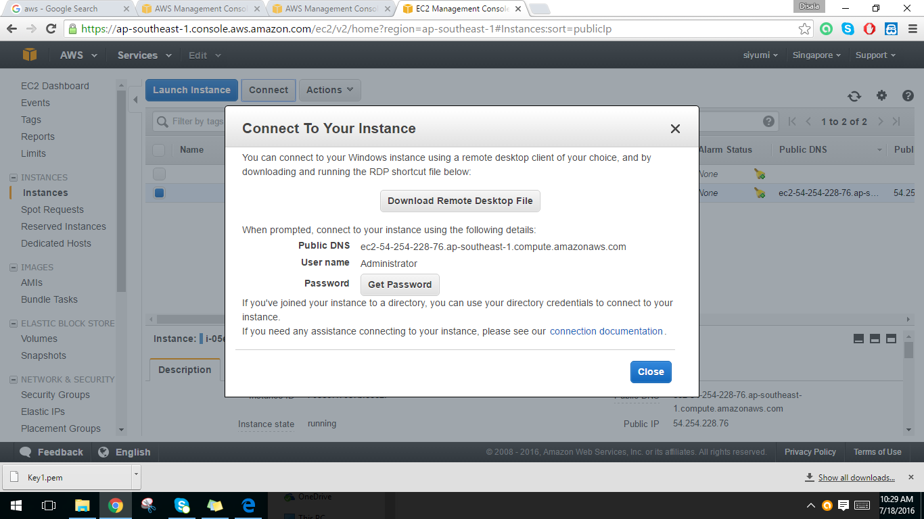

15. Then clicking choose file give the path to the earlier downloaded key pair. (.pem file)

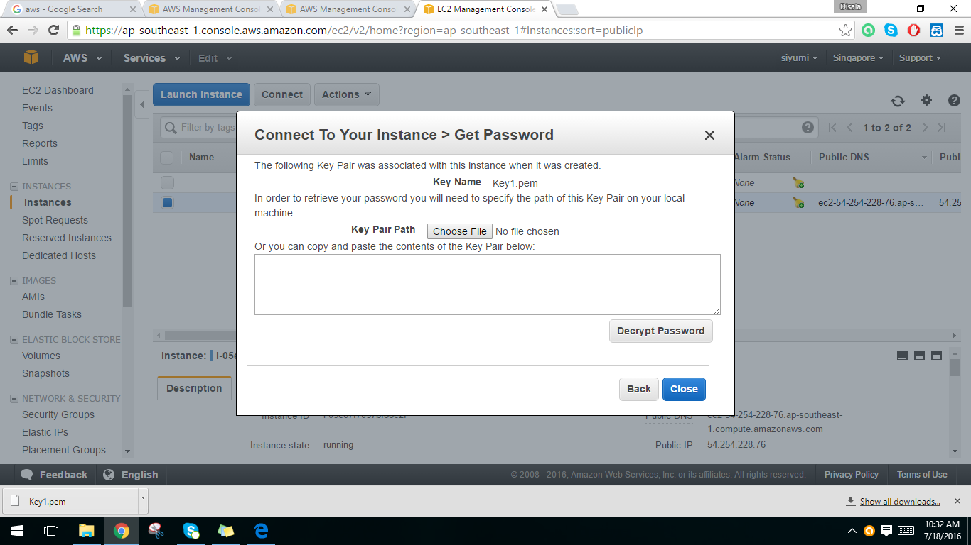

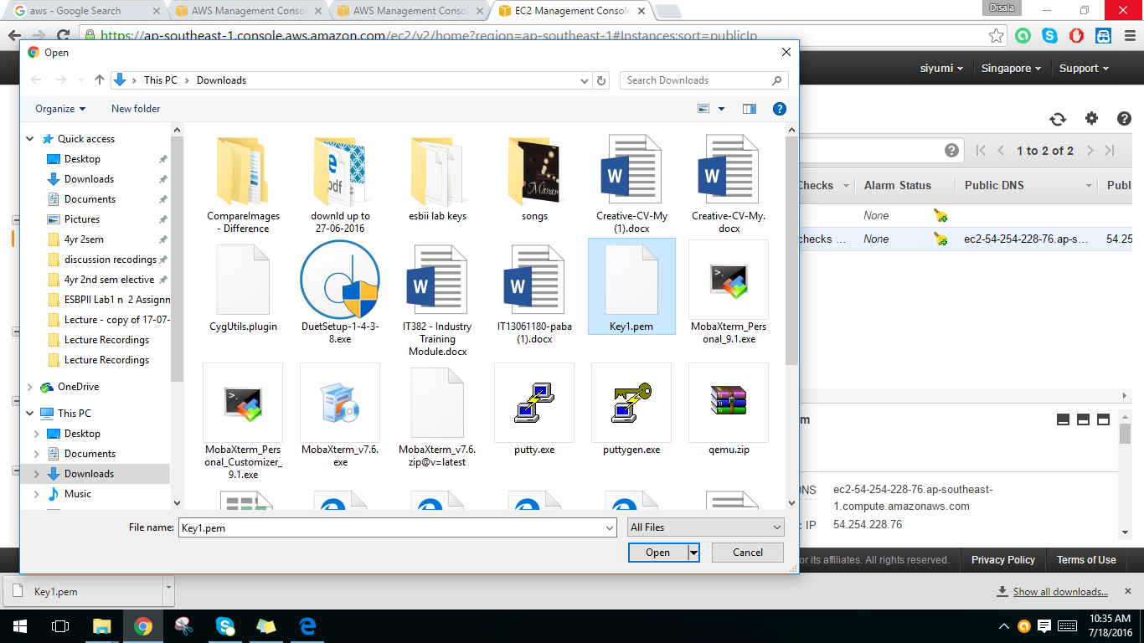16. Choose the downloaded .pem file.

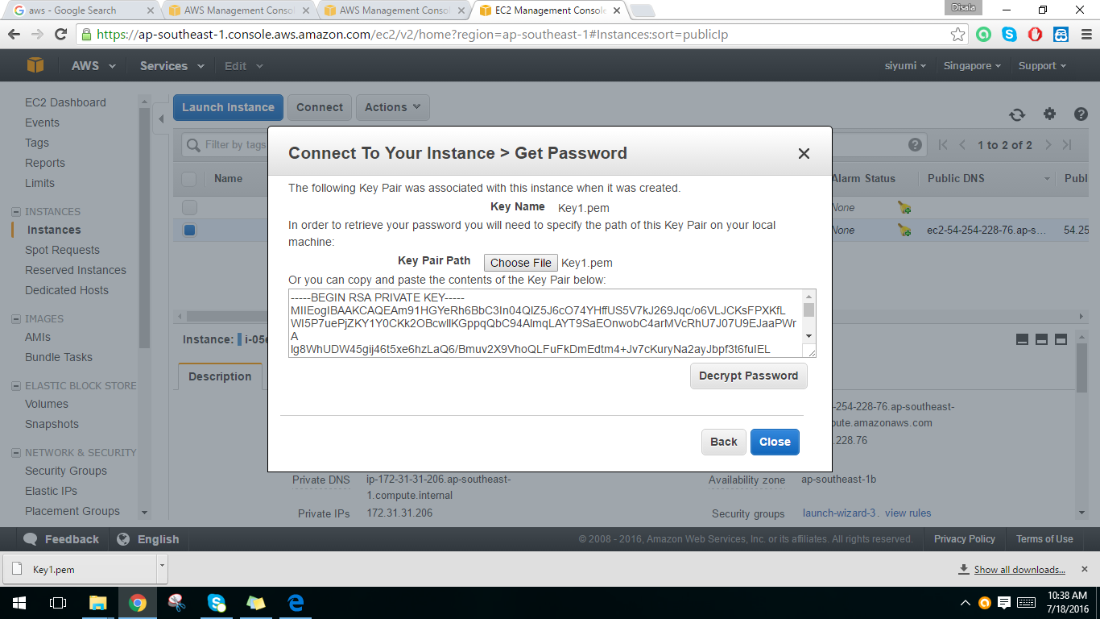17. Then decrypt the password.

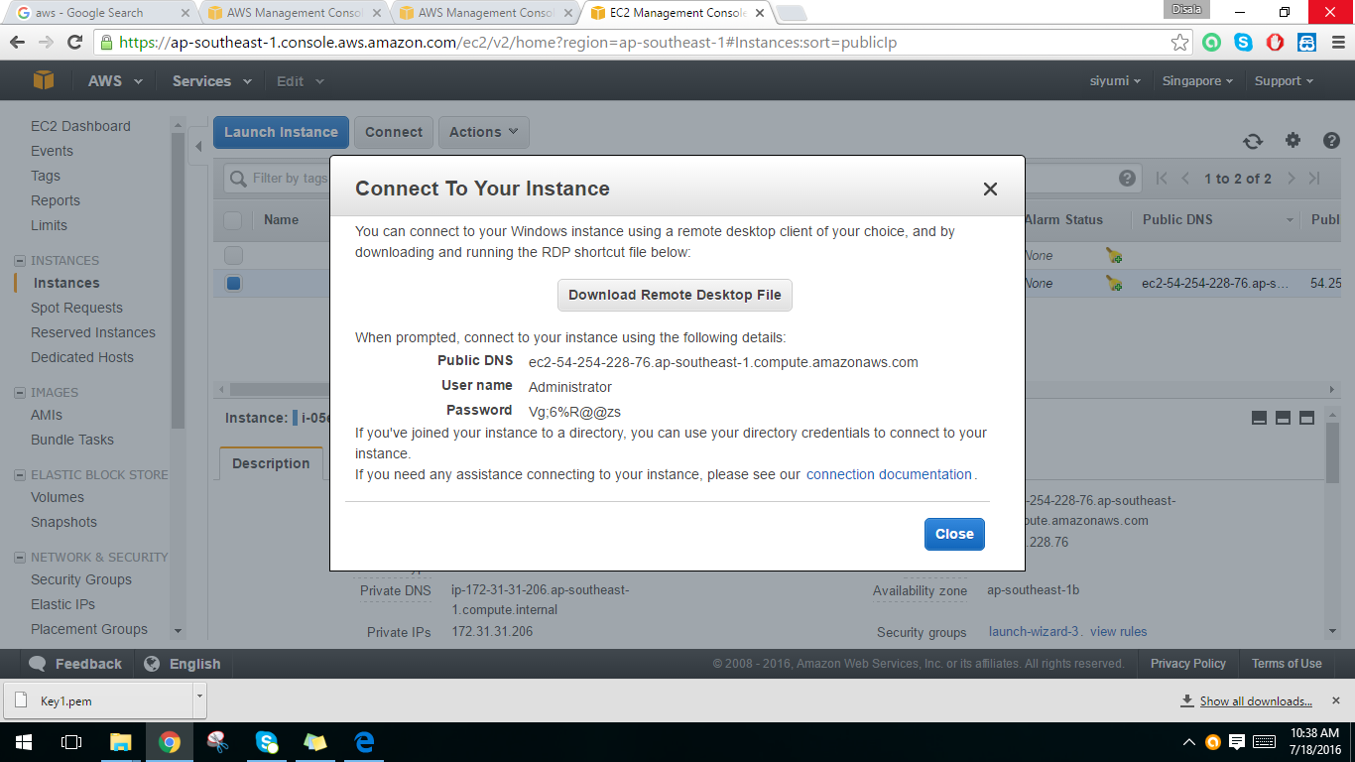18. So the decrypted password will appear.

19. Search the Remote Desktop Connection.

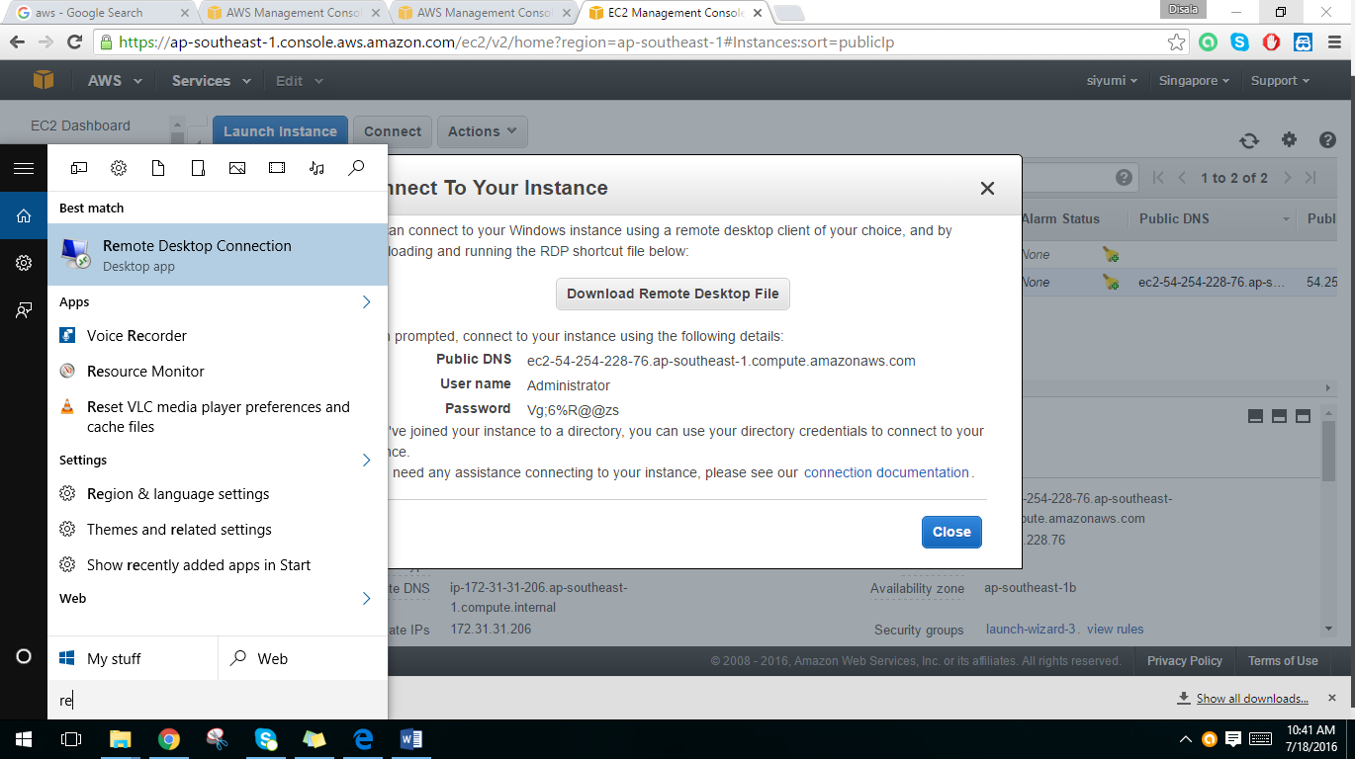

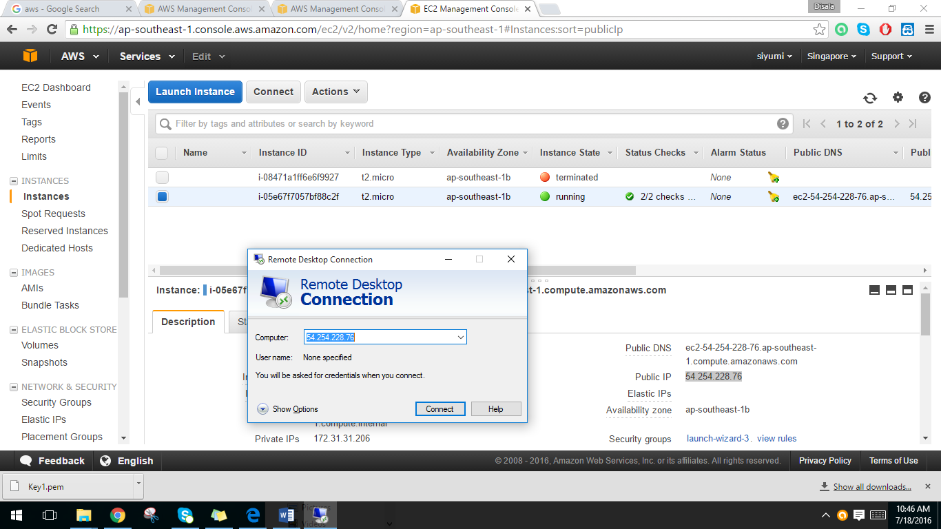20. Give the public IP as the remote computer IP. And click the Connect button.

21. Enter the username and password and then press ok.

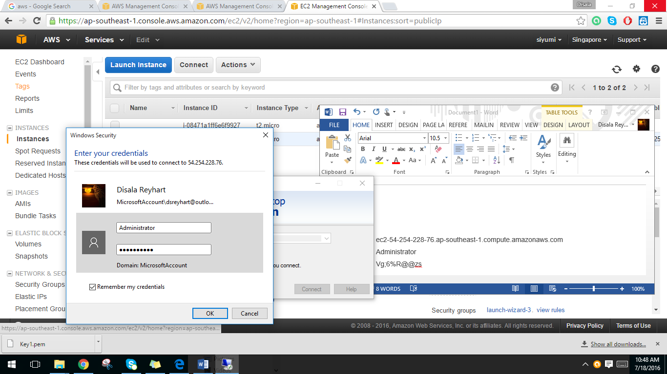

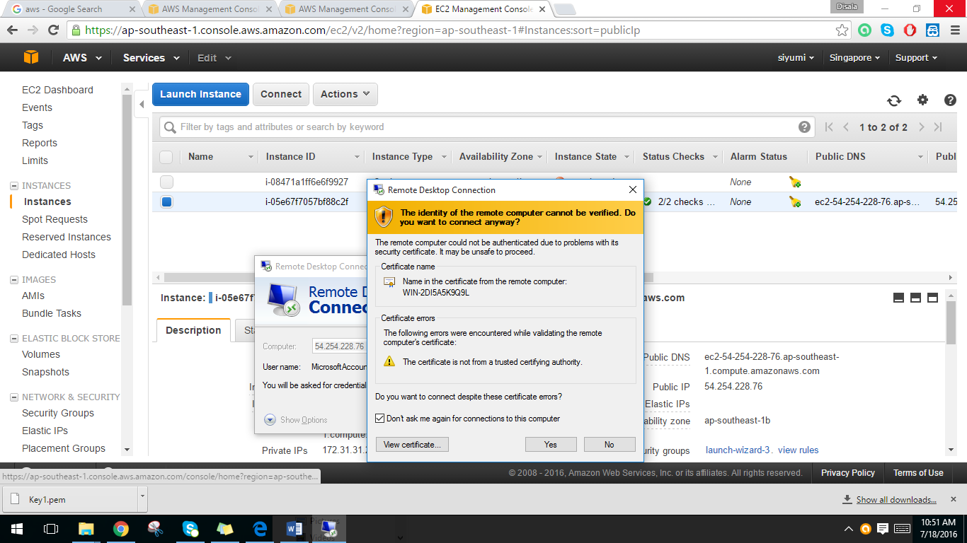

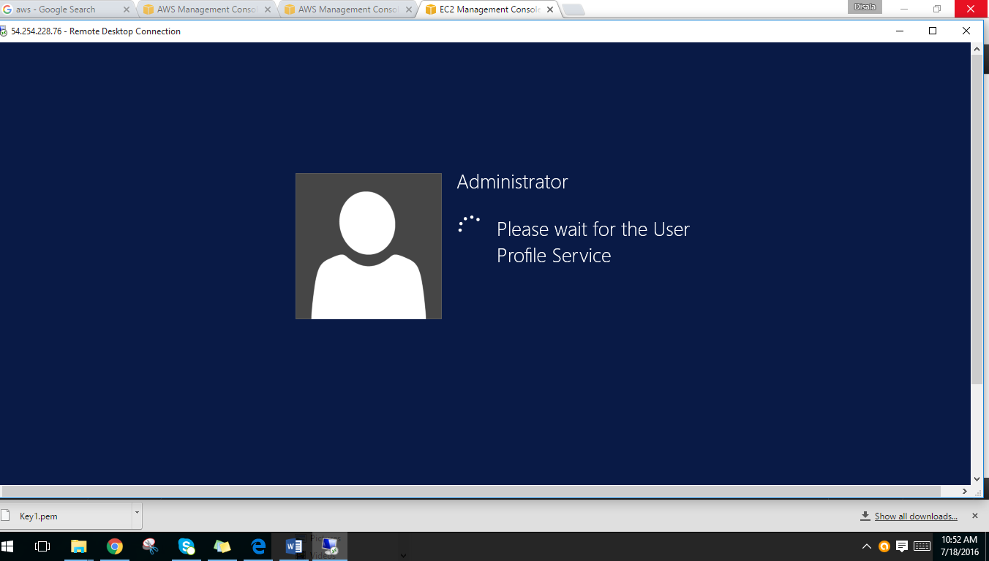22. After click Yes, Windows instance will appear.

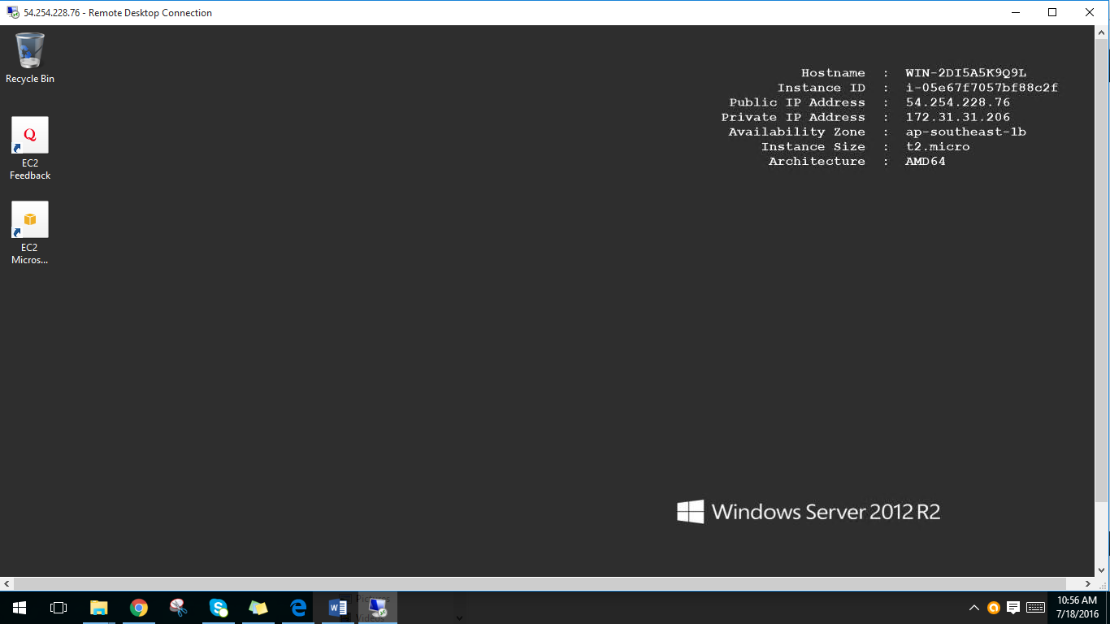

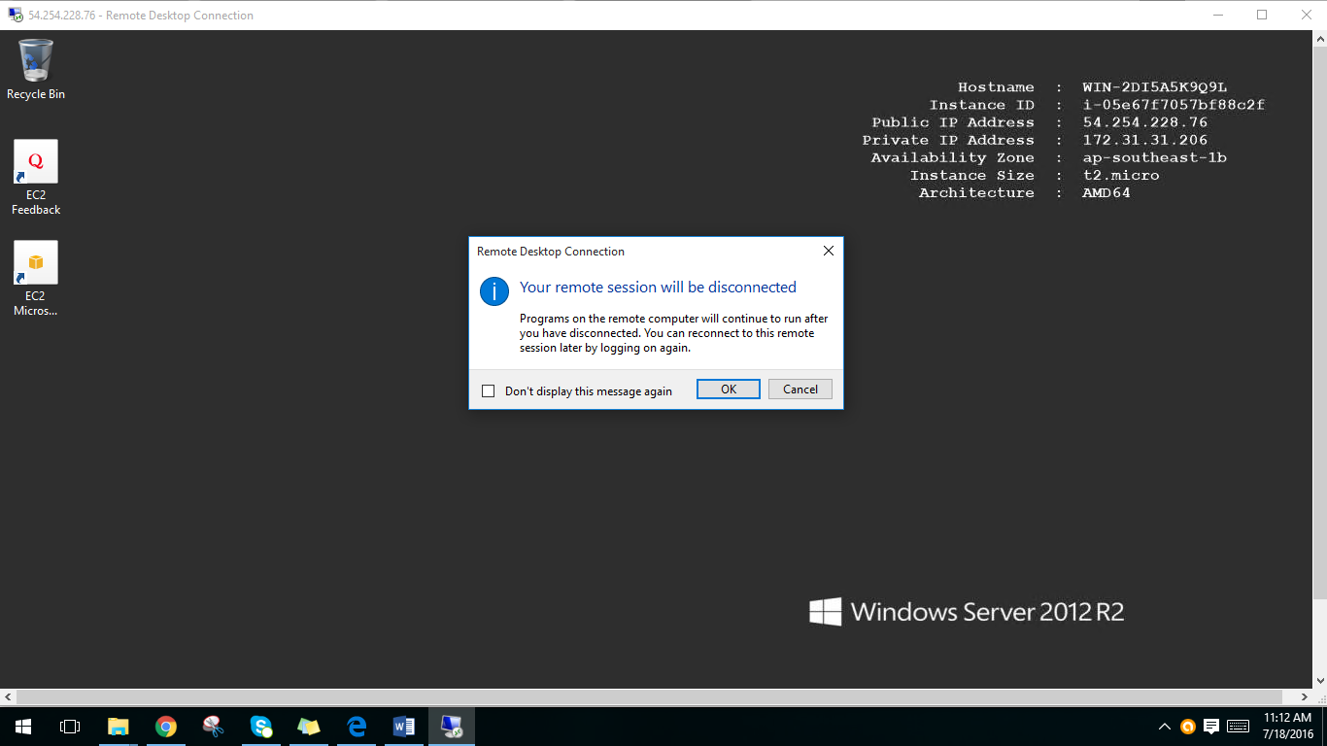

20. After the work have done terminate the created instance.

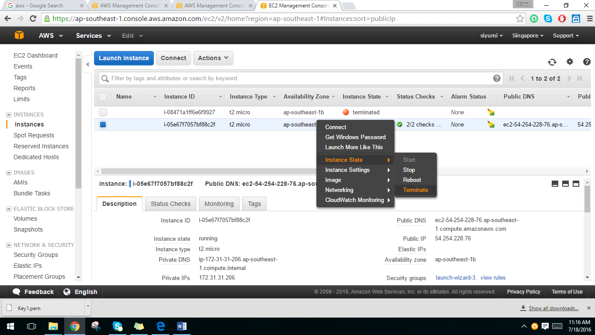

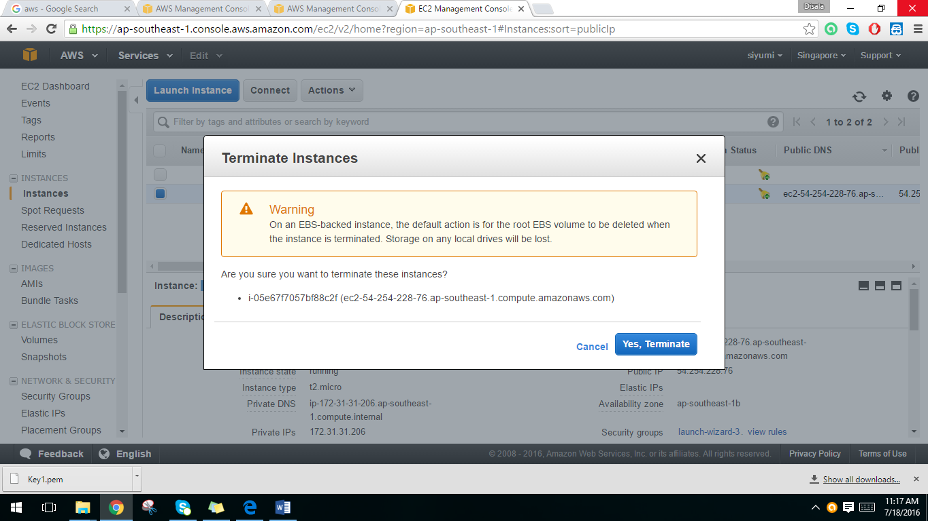

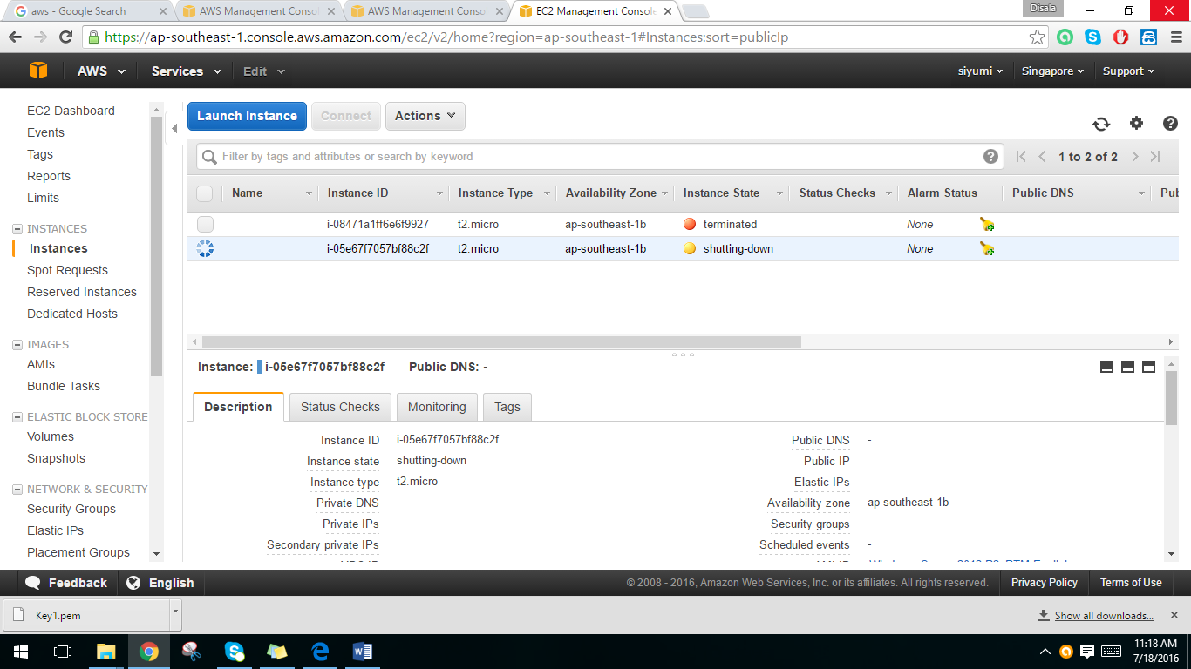

**Lab 02 -** Getting started with Amazon Linux instance

1. Create EC2 instance in Amazon Web Services.

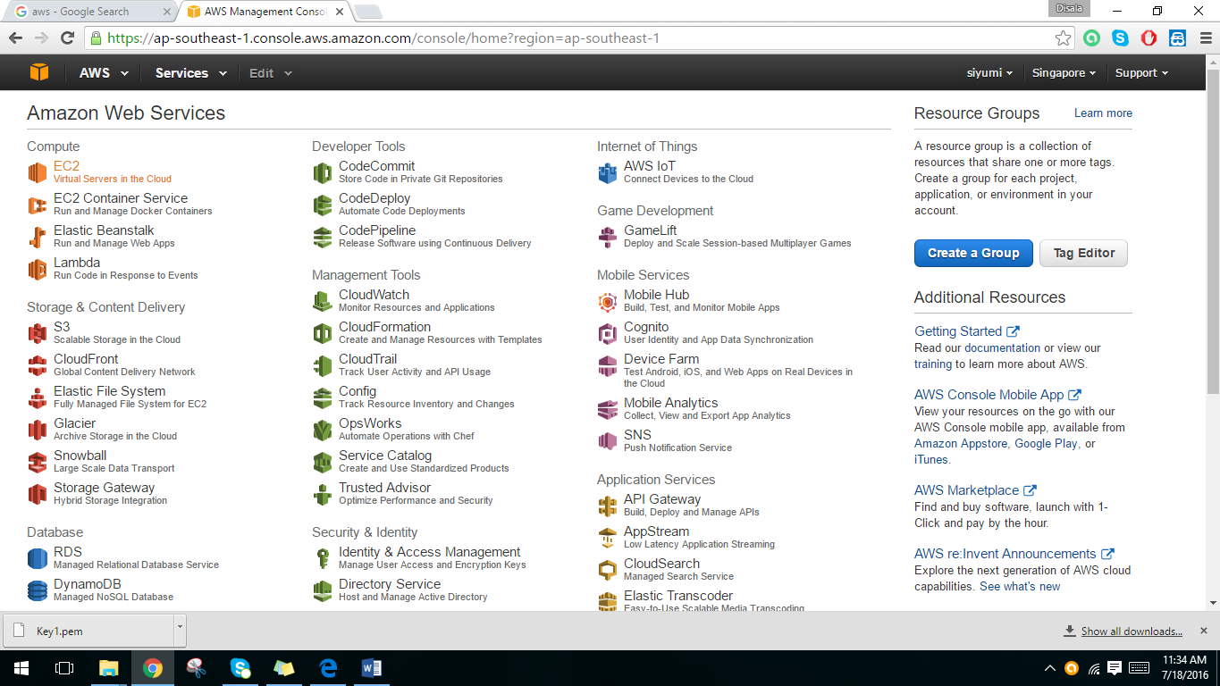

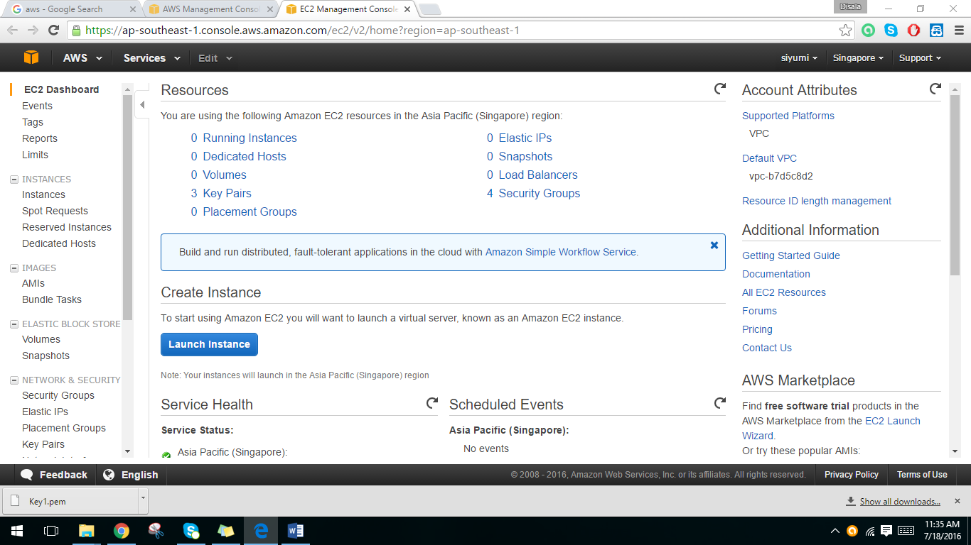2. Launch the instance.

3. Select Amazon Linux AMI or Red Hat Enterprise Linux.

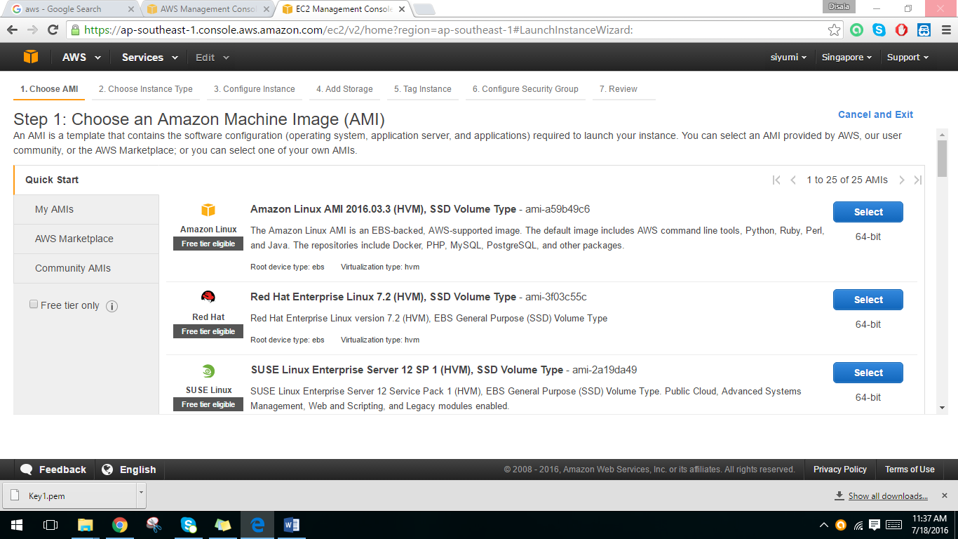

4. Choose t2.micro as the instance type. And click on the configure instance details button.

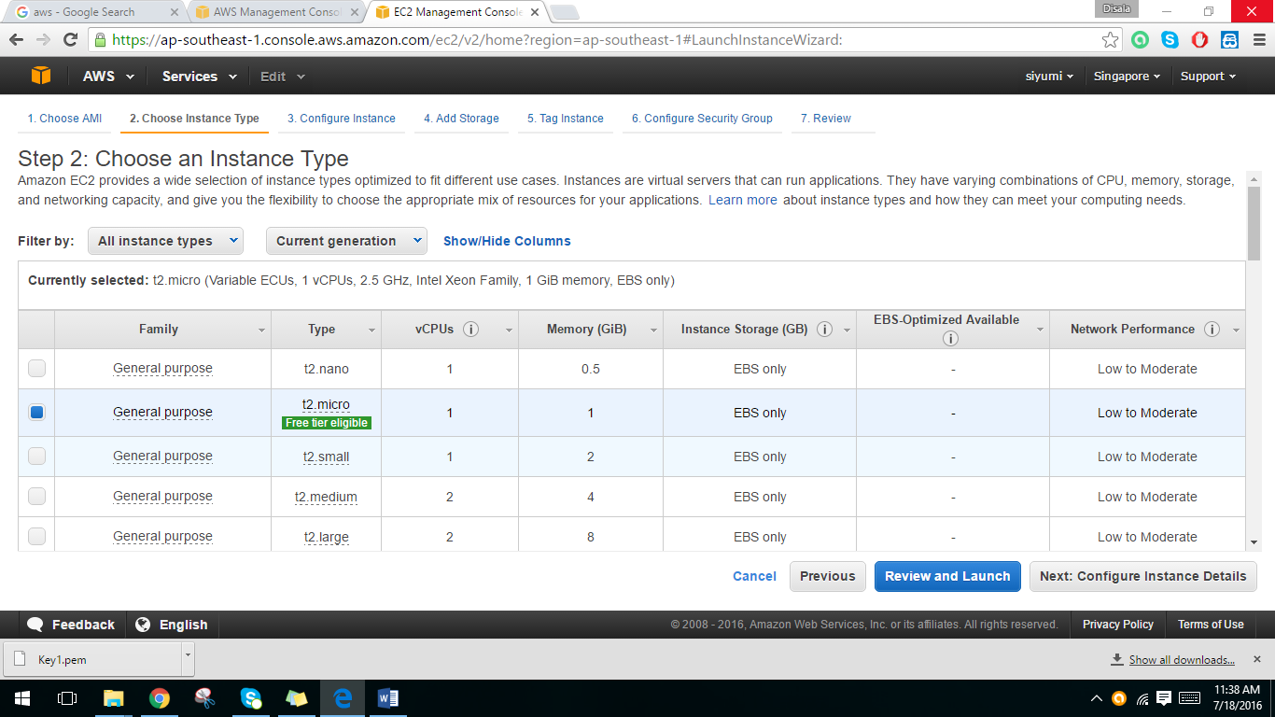

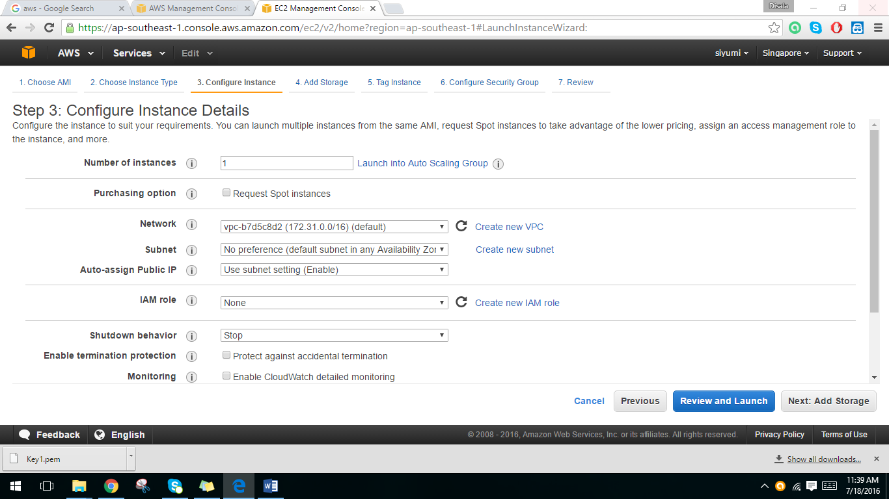5. Click Add Storage button.

6. Add Storage. Then click Tag Instance button.

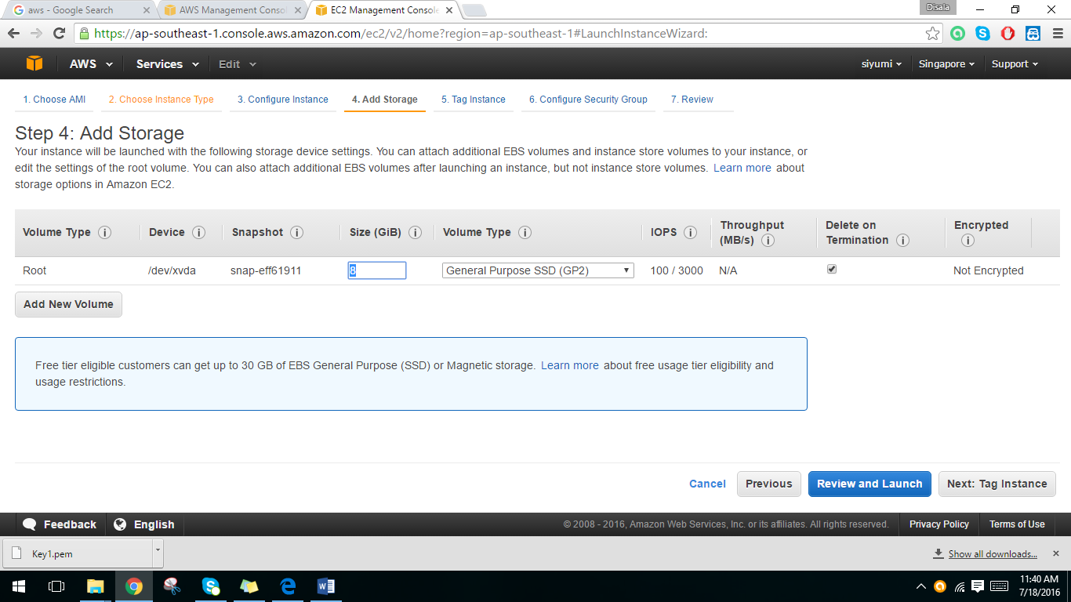

7. Tag Instance. Then click Configure Security Group.

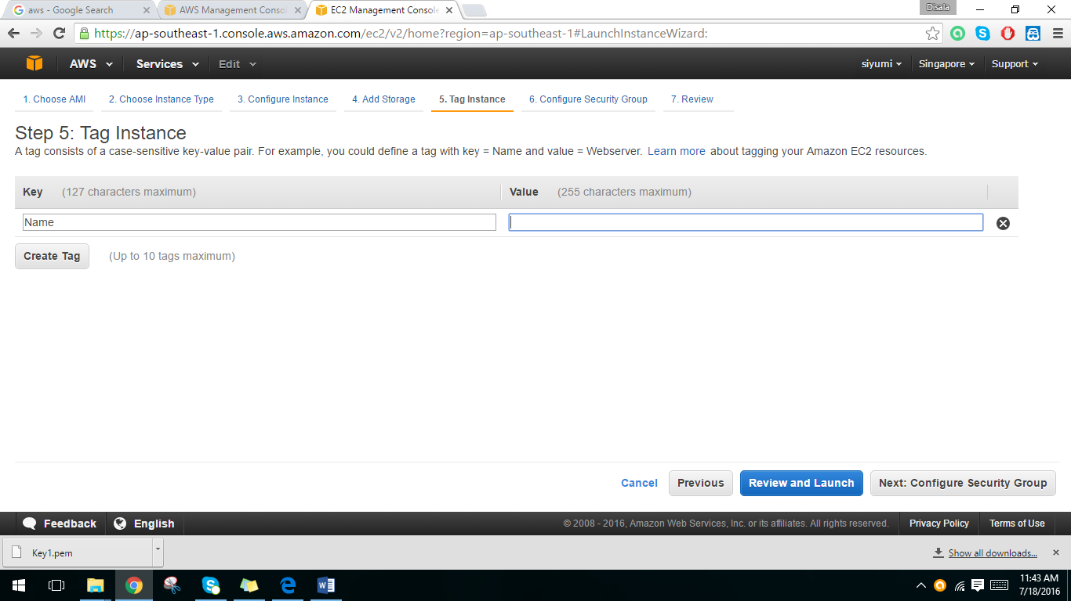

8. Configure security group. Then click Review and Launch button.

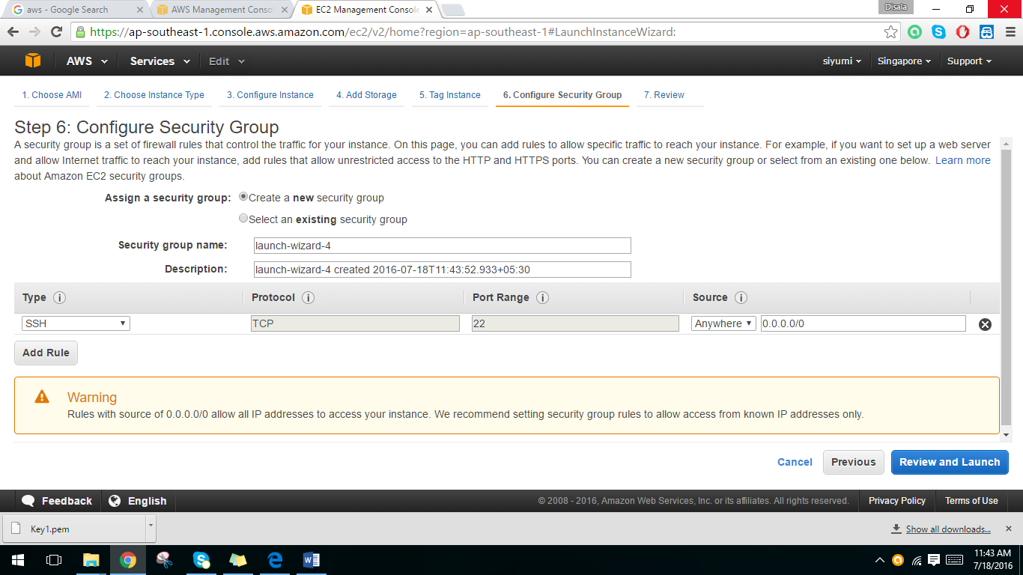

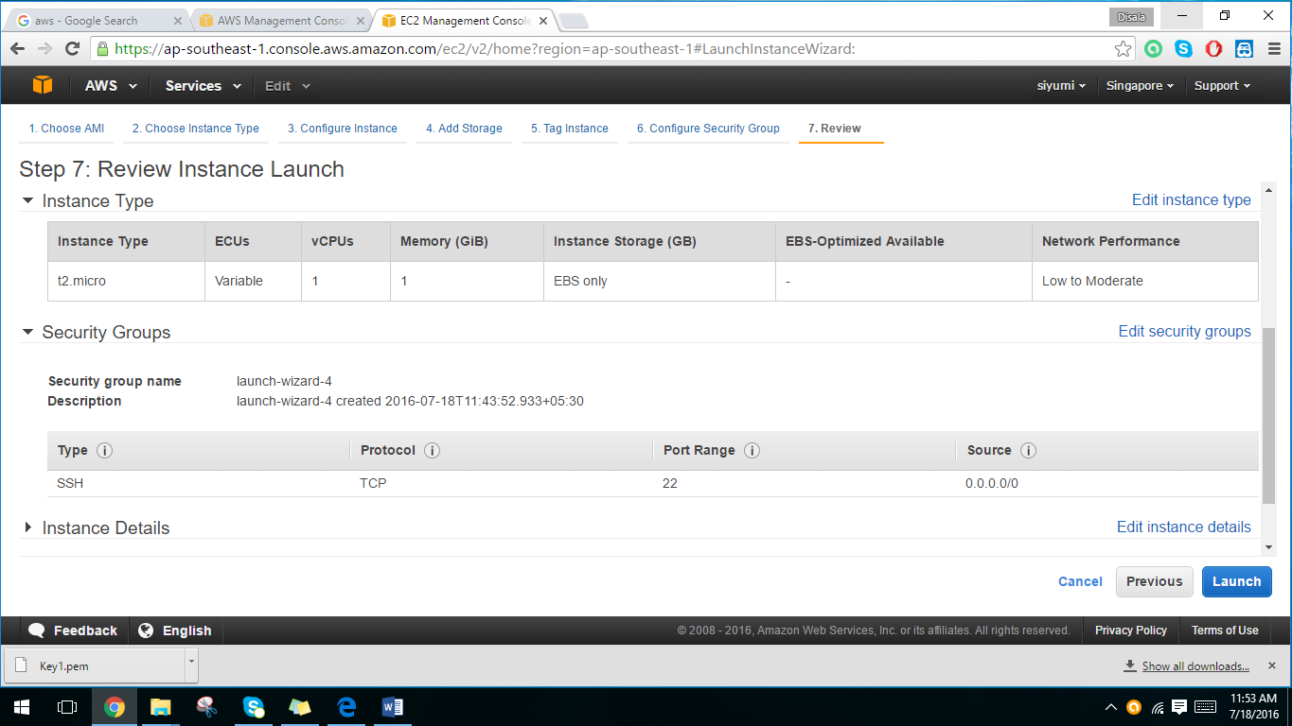9. Review instance launch. Then click launch button.

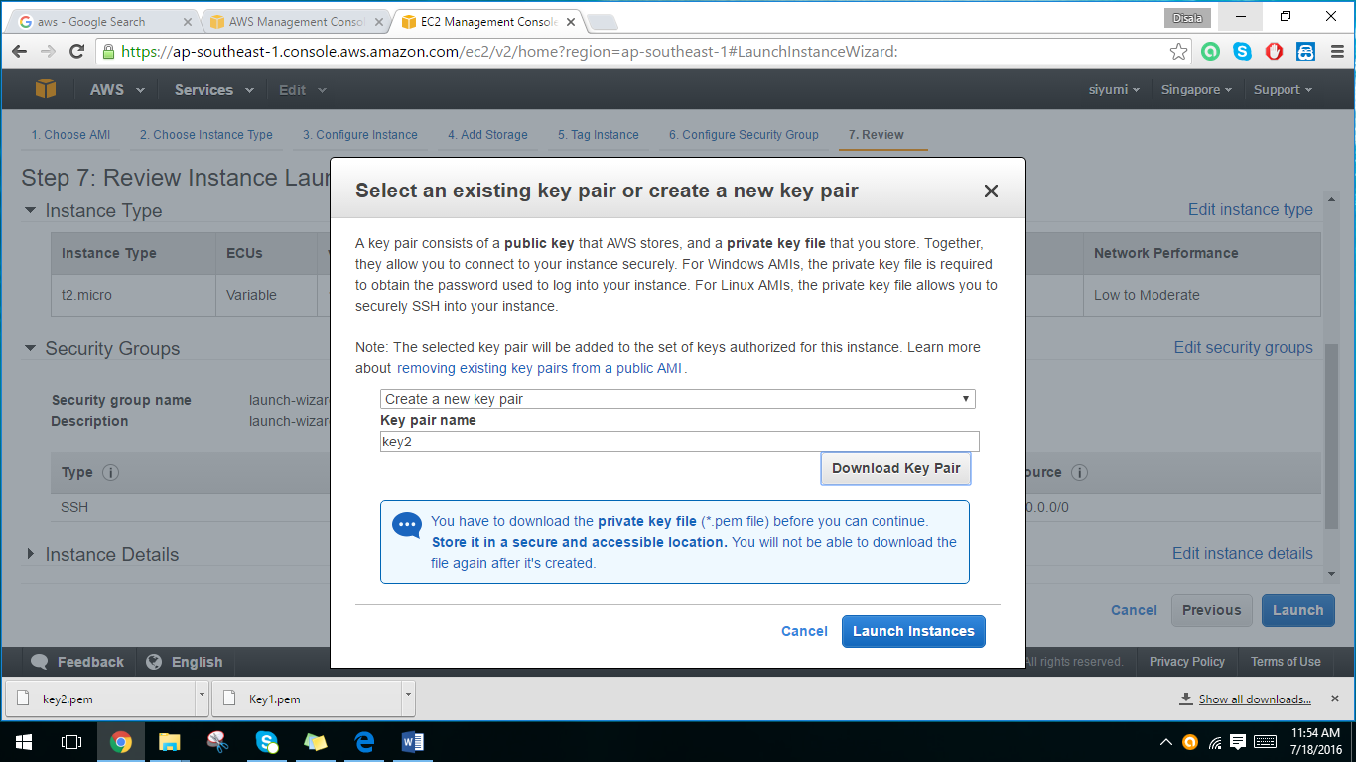10. Create a new key pair and download it. Then click launch instance.

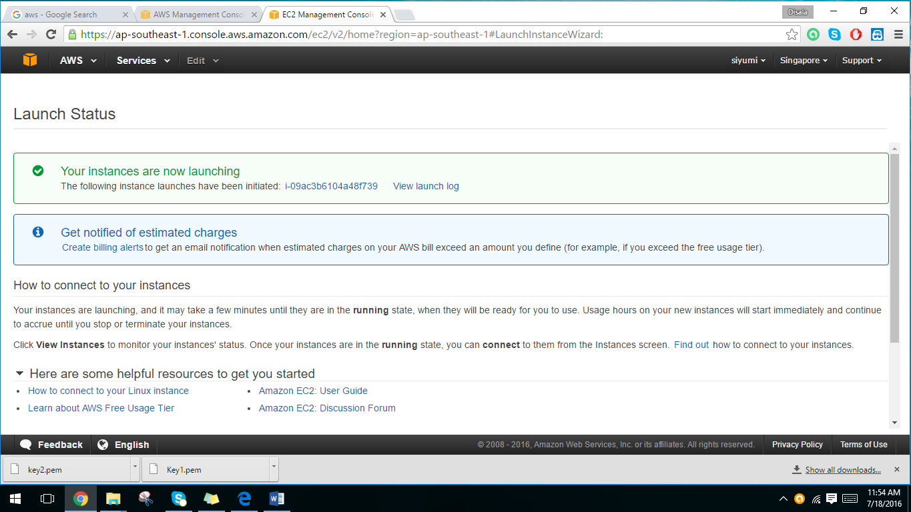11. Status of the instance.

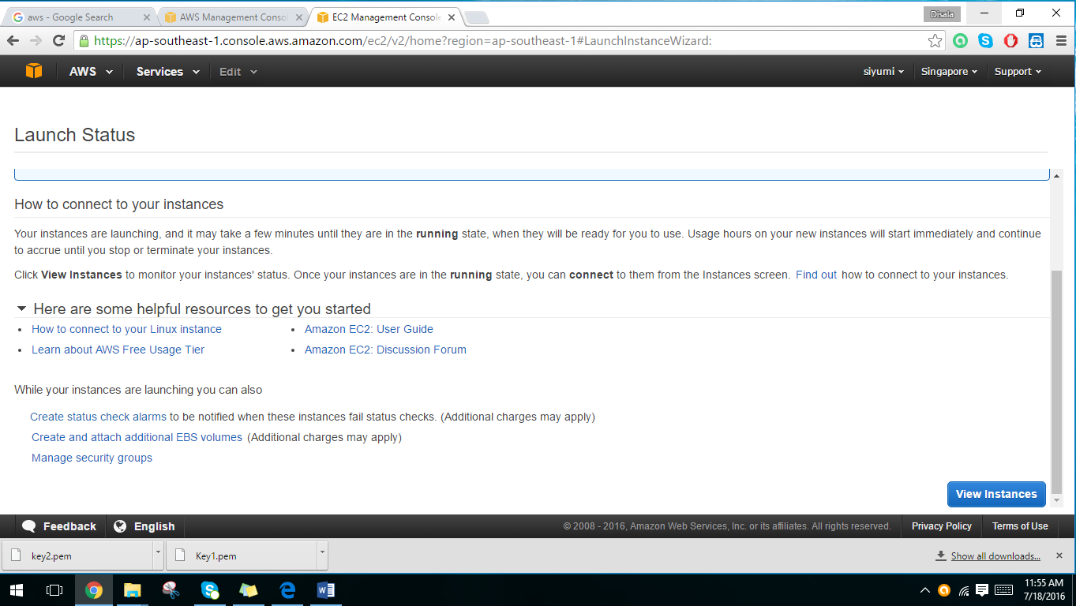12. Click the view instance button.

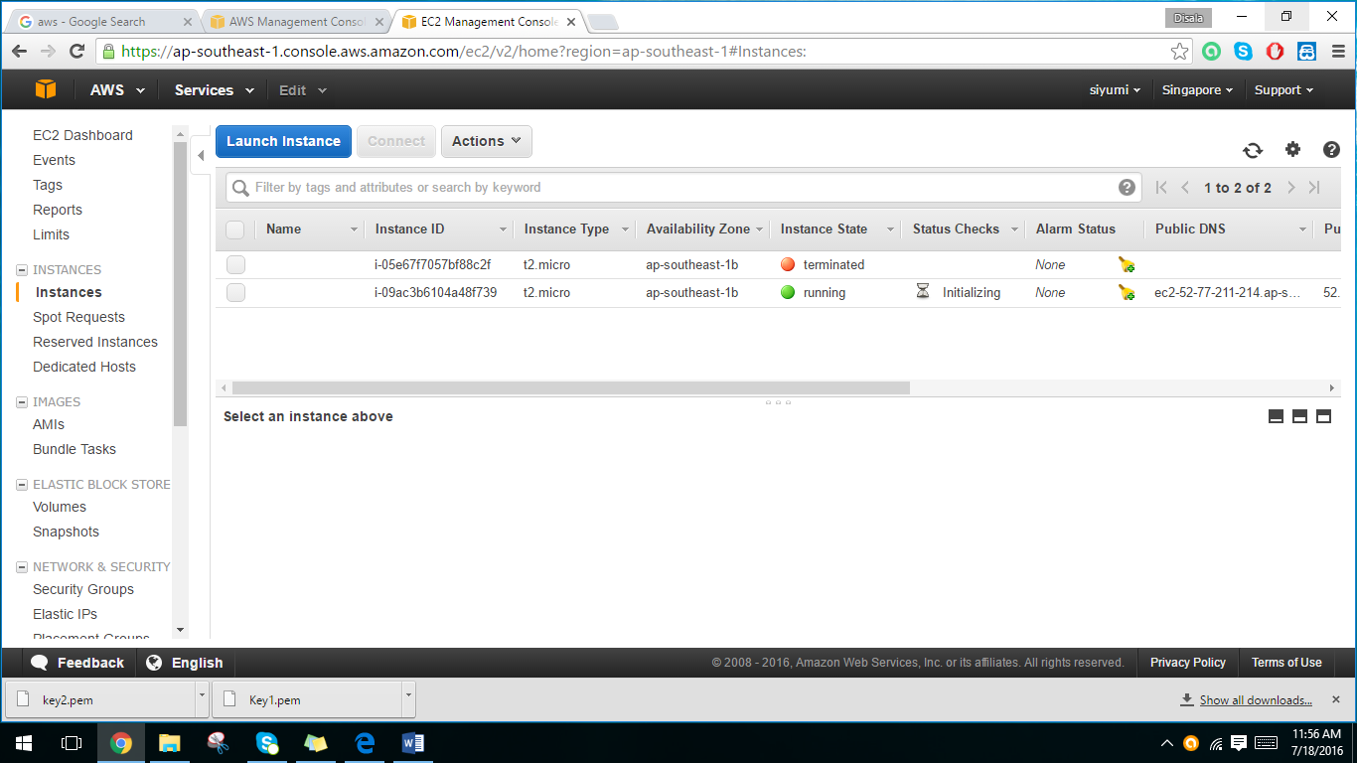13. Now the instance details will appear. Instance is up and running.

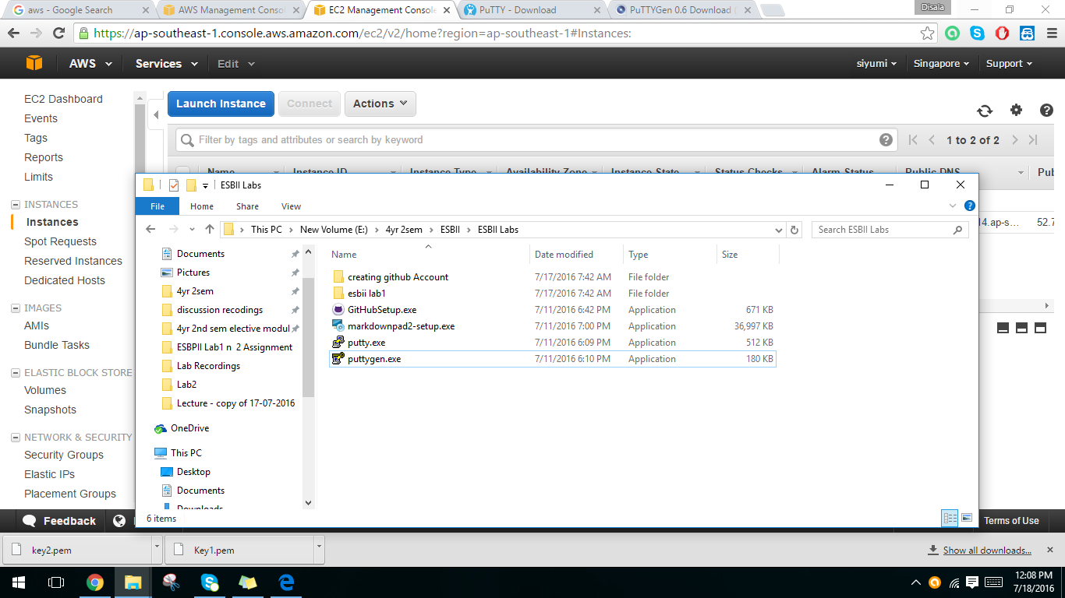14. Download PuTTY and PuTTYgen.

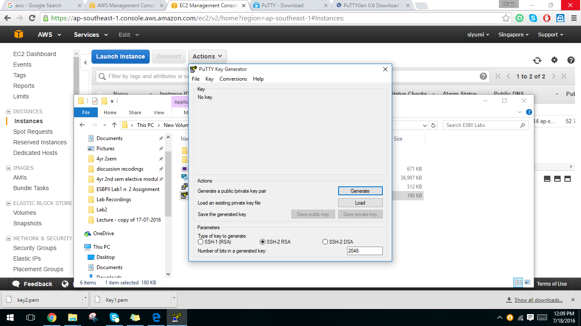15. Double click on puTTYgen. Then generate the private key.

16. Load the private key. (.ppk)

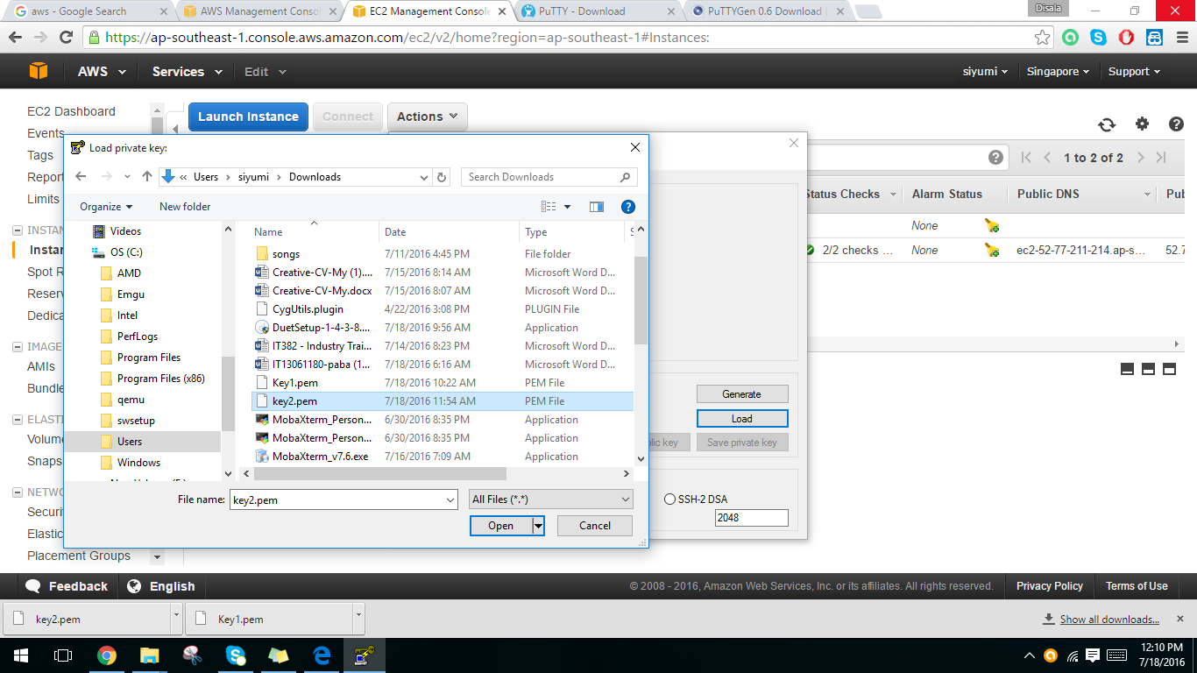

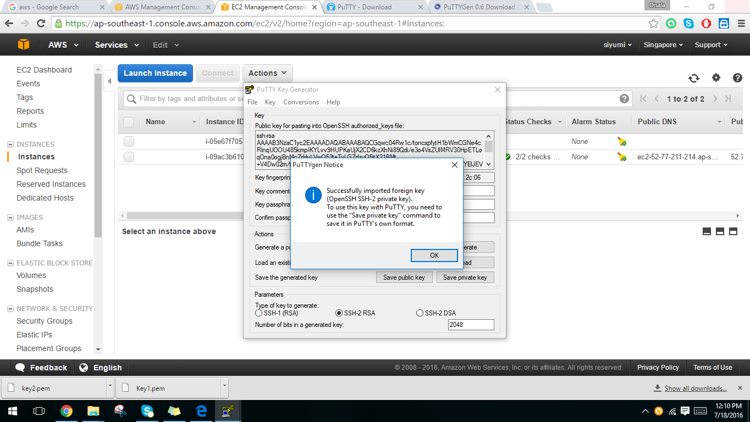17. Double click on puTTY.

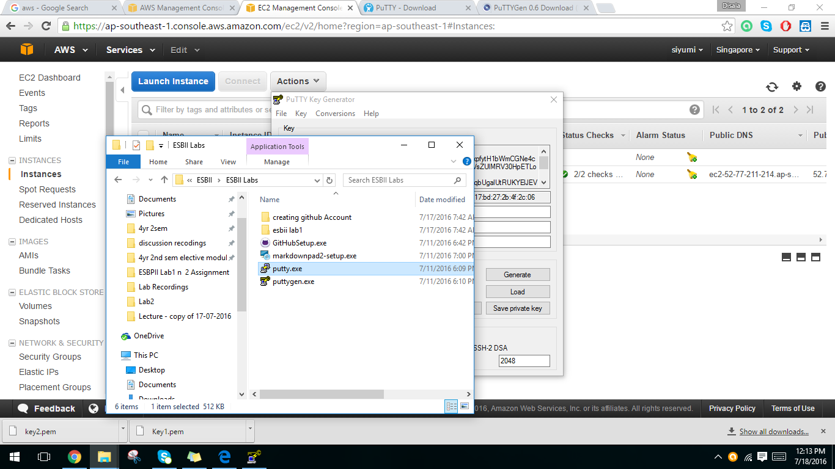

18. Give the public DNS as the host name. And create a session and save it. (Category🡪 session)

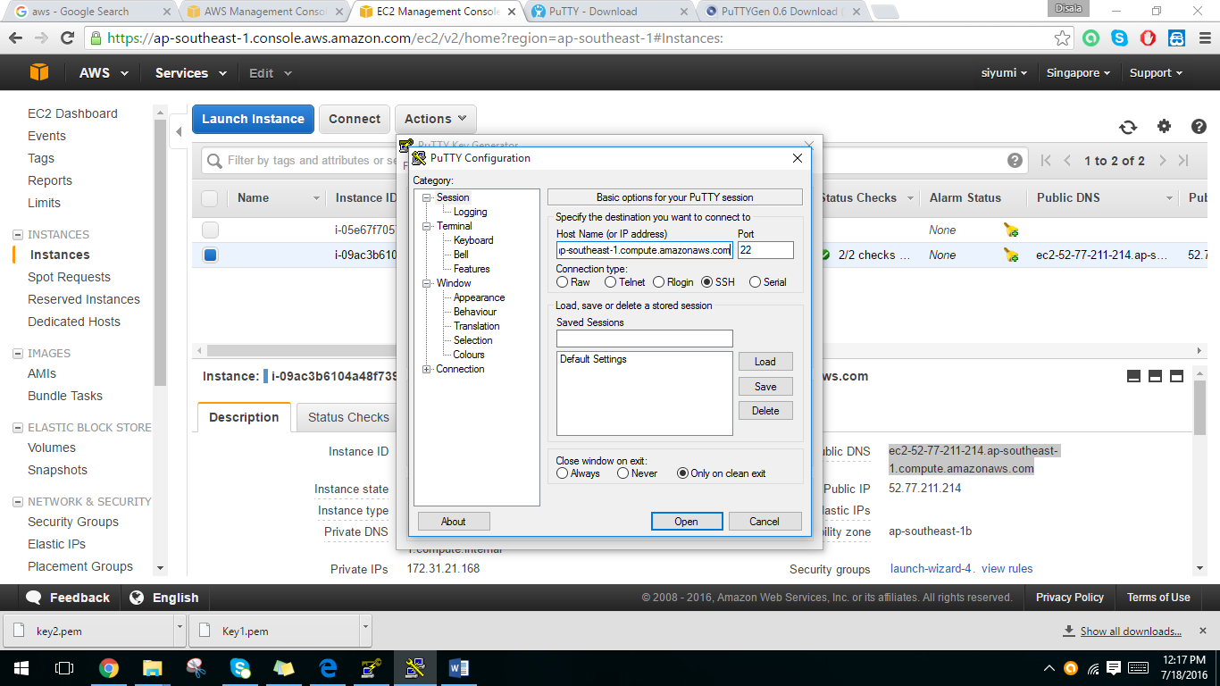

19. Go to category🡪 connection🡪 SSH 🡪 Auth

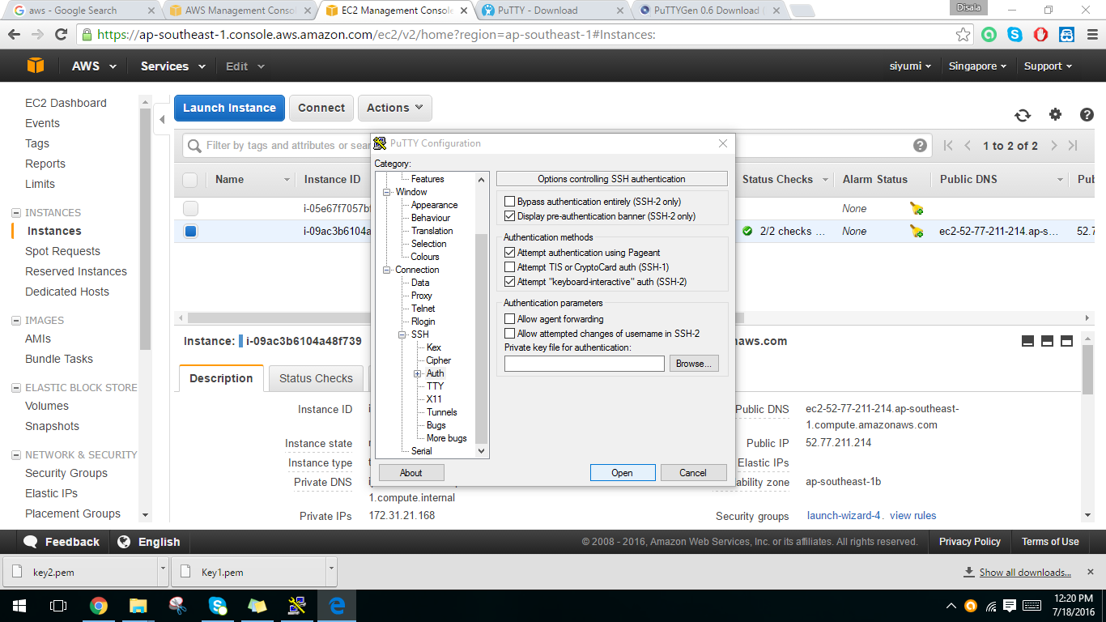

20. Then brown the key (.ppk) previously generated by puTTYgen.

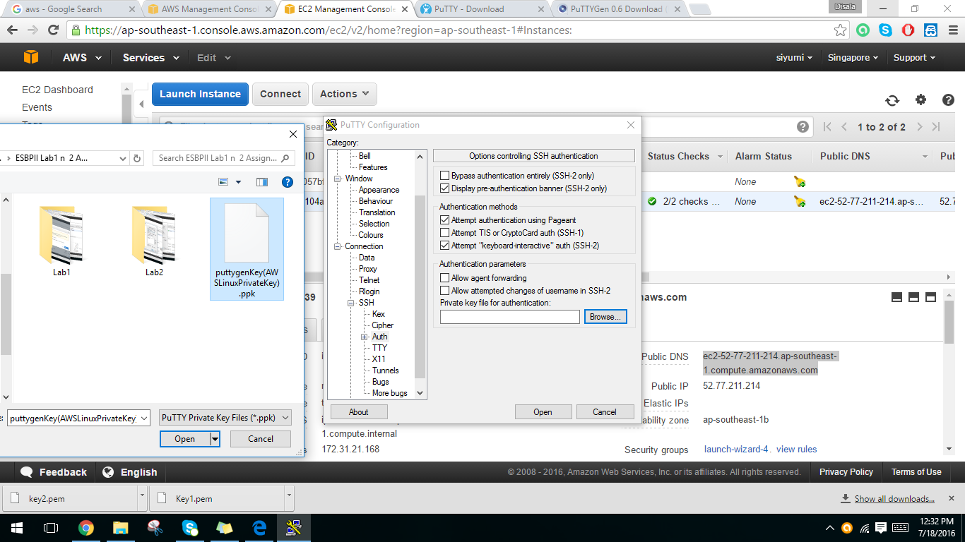

21. Give ec2-user to login.

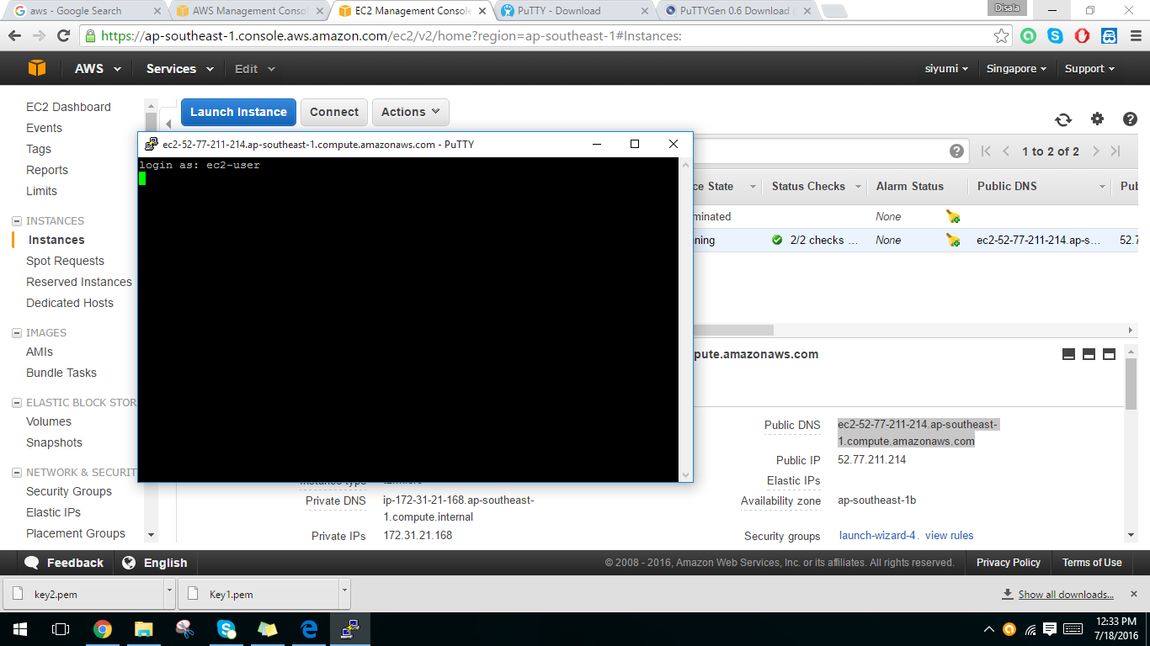

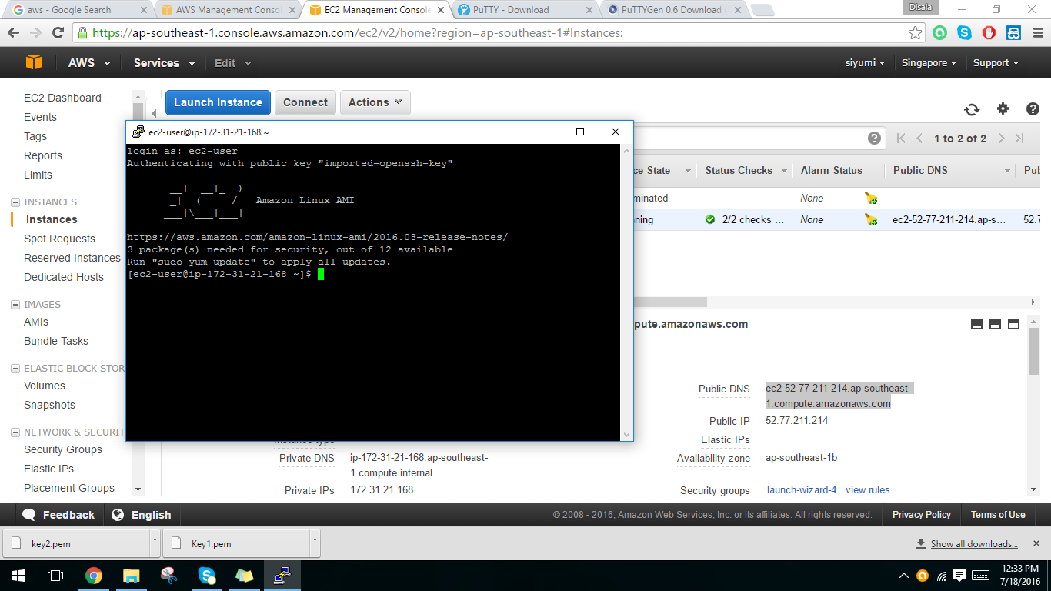22. Then Amazon Linux instance will appear.

23. Terminate the Linux instance.

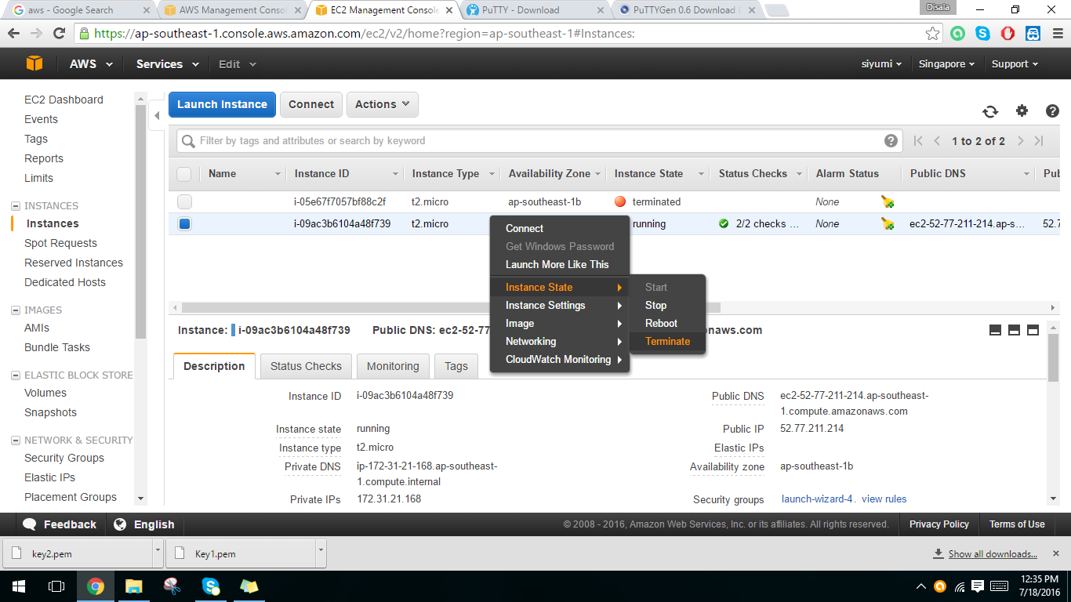ss

**Lab 03 -** Creating a MySQL DB Instance and Connecting to a Database on a MySQL DB Instance

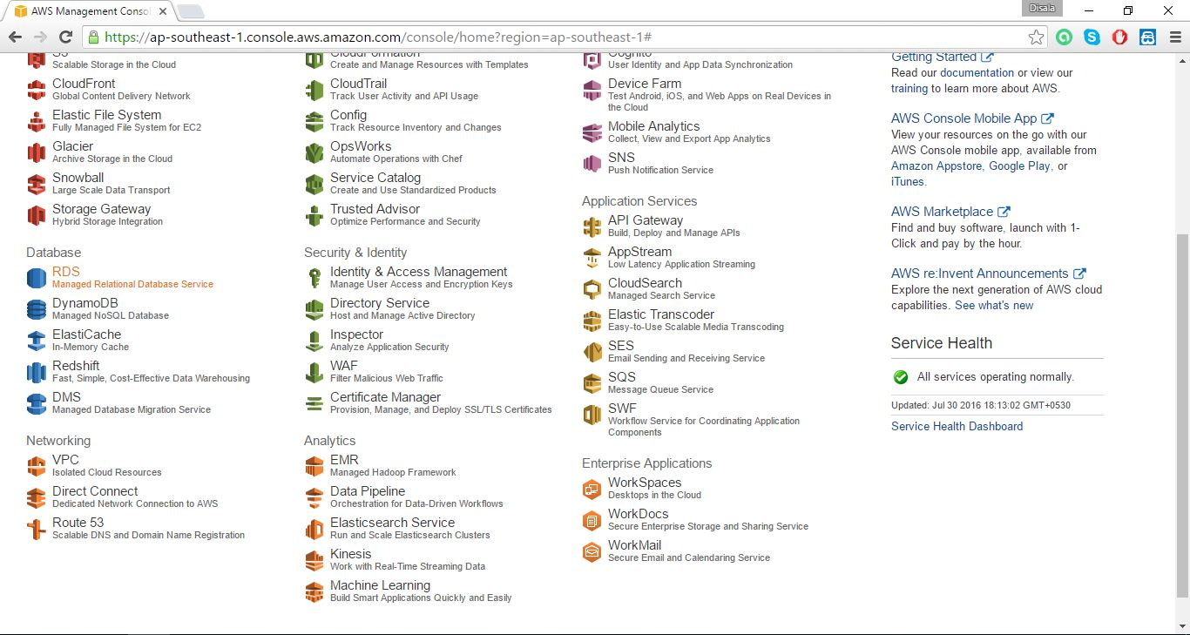1. Creating RDS instance.

2. Click on Launch instance button.

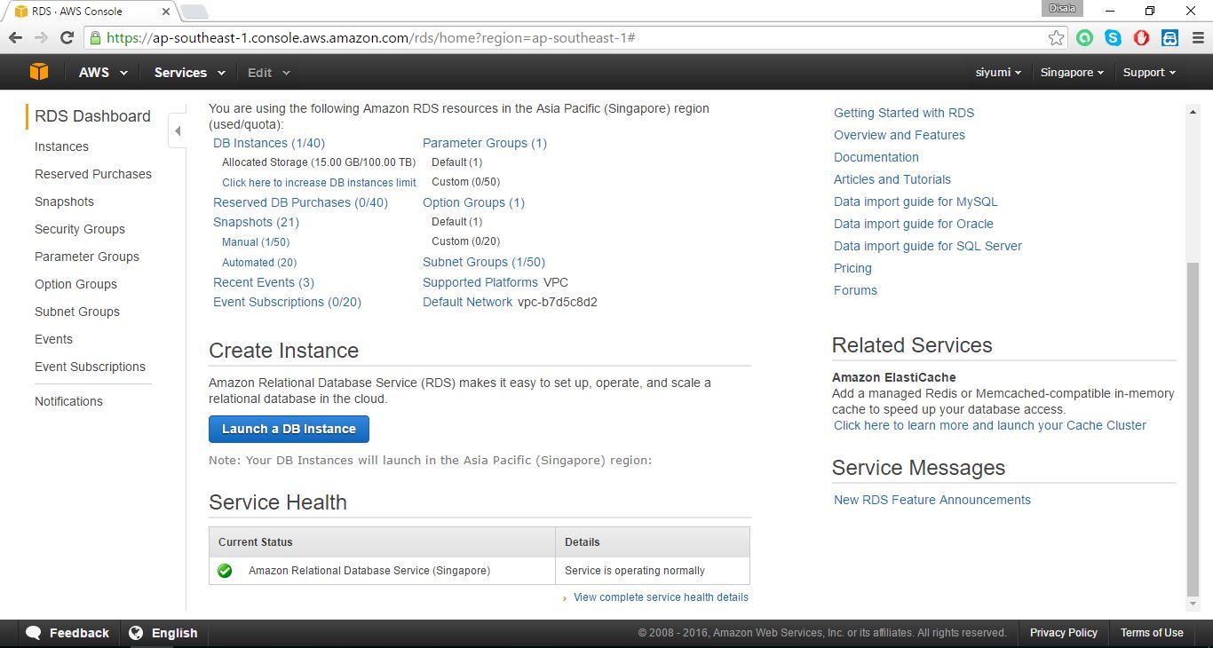

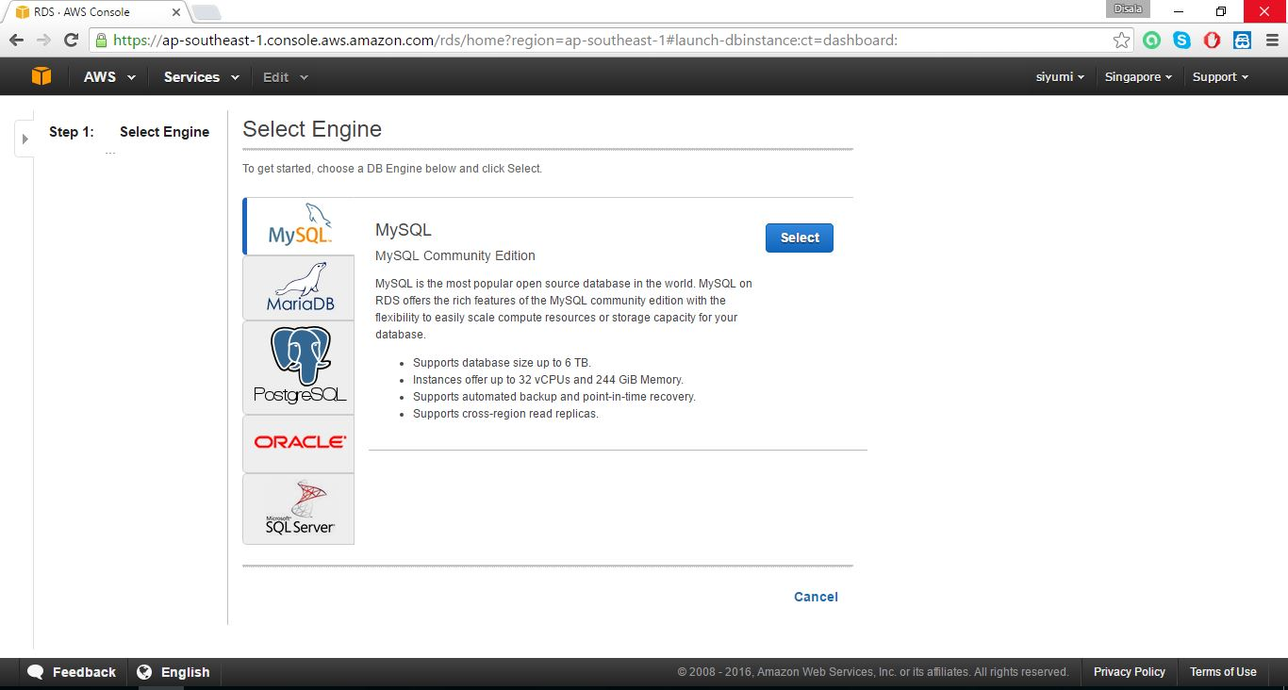3.Select MySQL Community Edition.

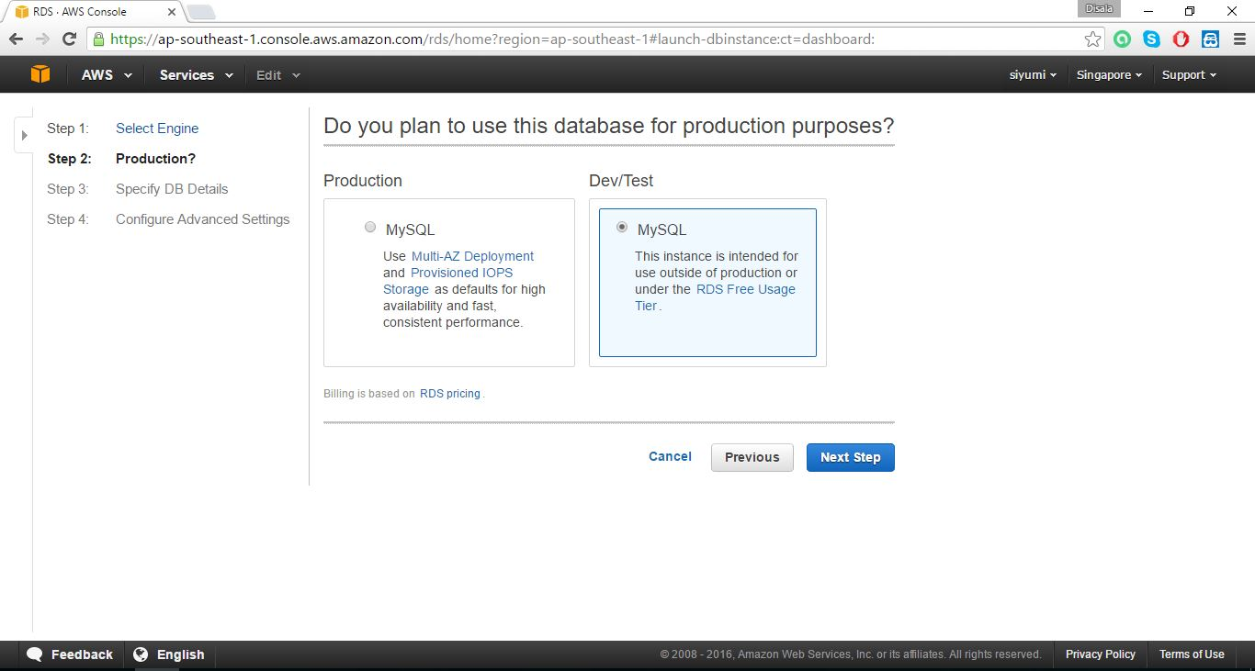

4. Specify DB Details.

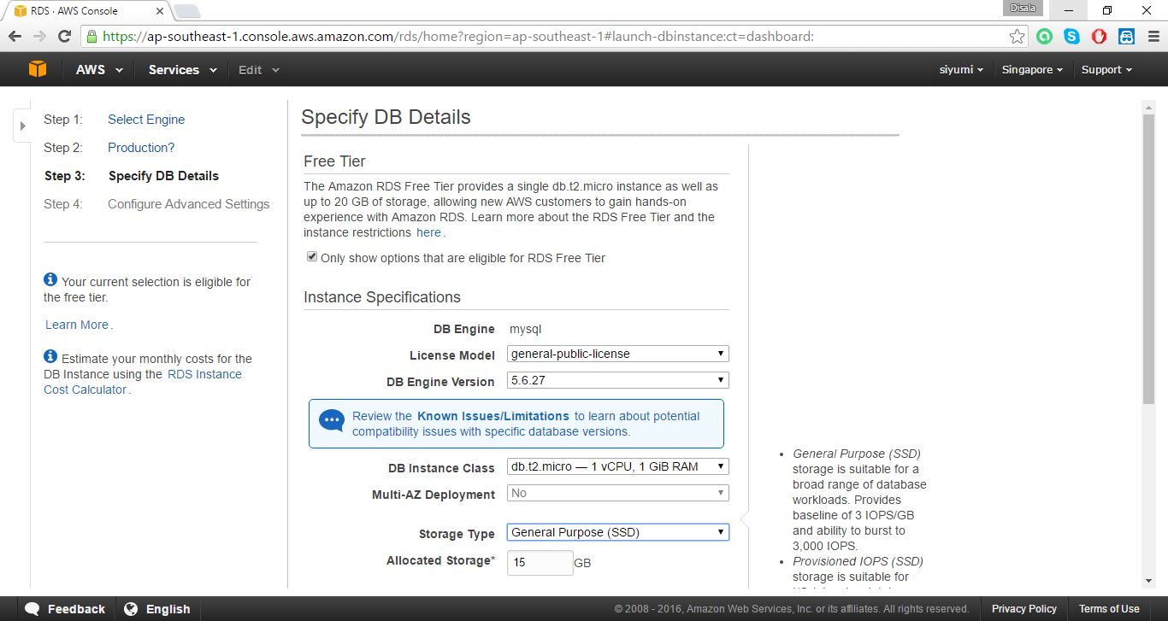

5. Set DB instance

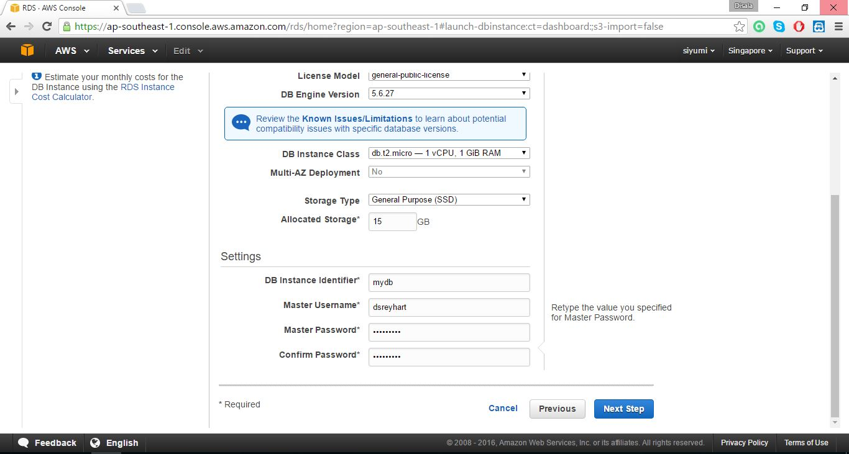

6. Configure advance settings.

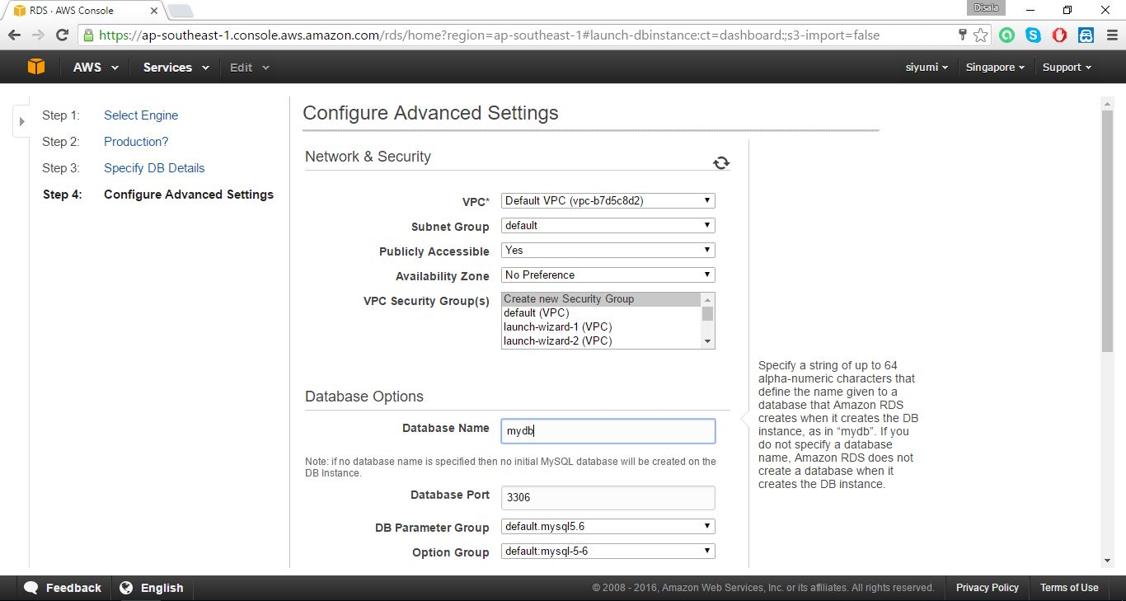

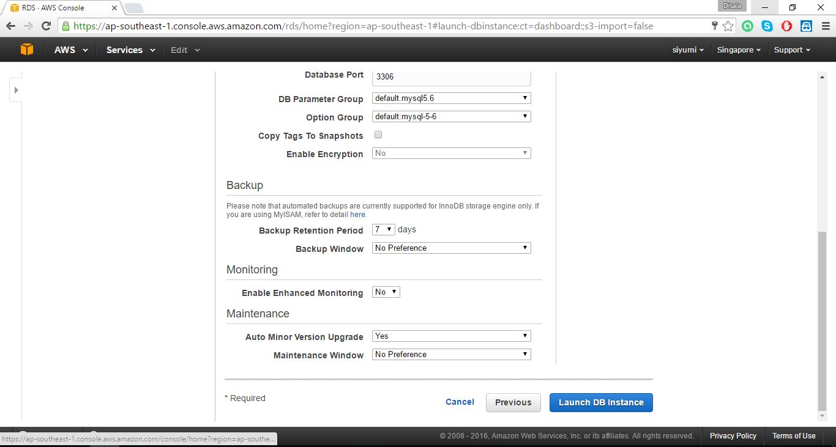

7. Click on view DB instances.

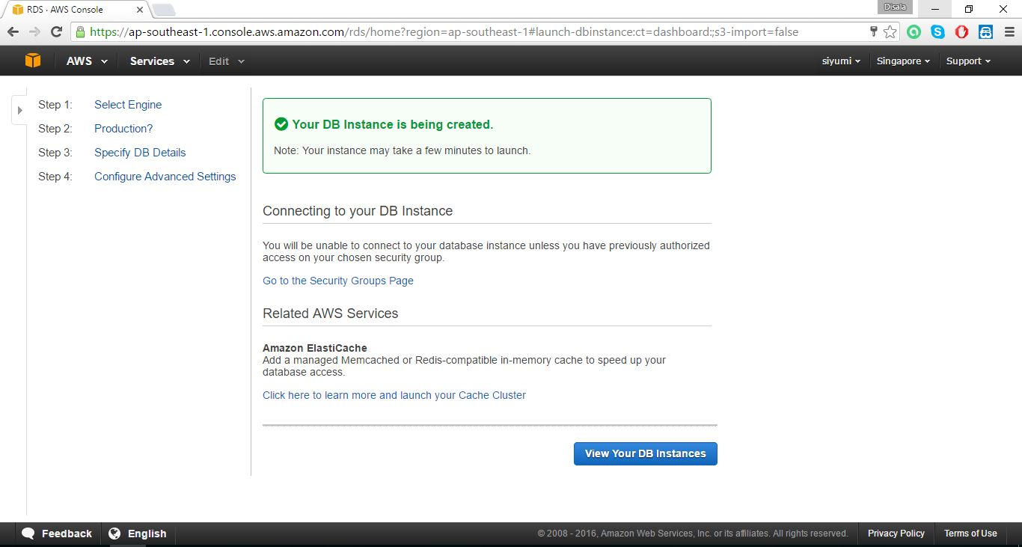

8. Wait until DB instance status is change to avable.

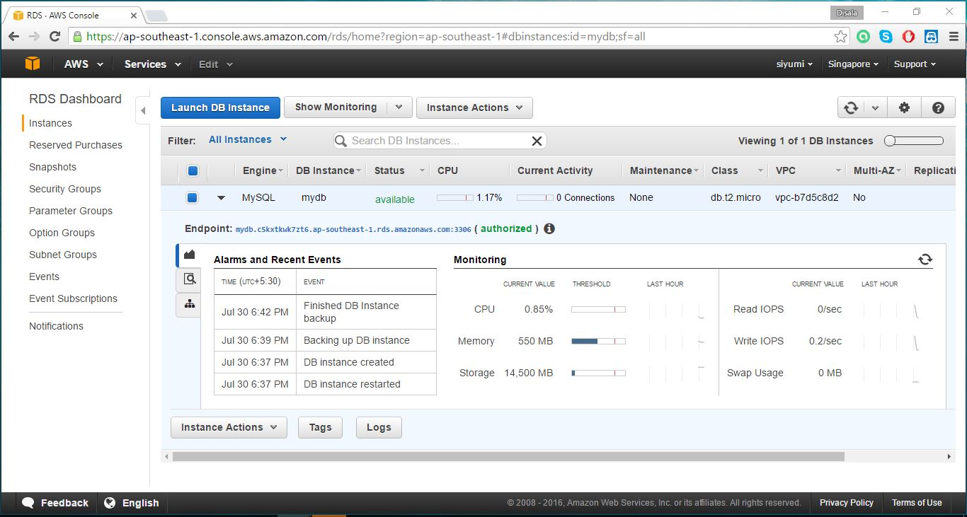

9. Open MySQL workbench.

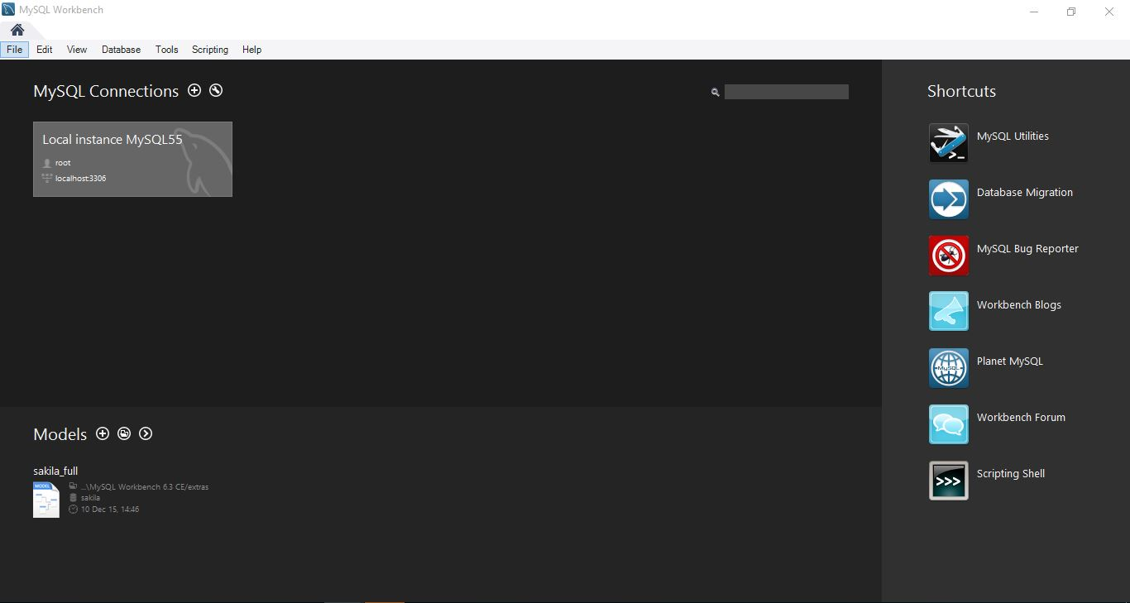

10. Create new connection and fill details from aws db instance. Then press test connection button.

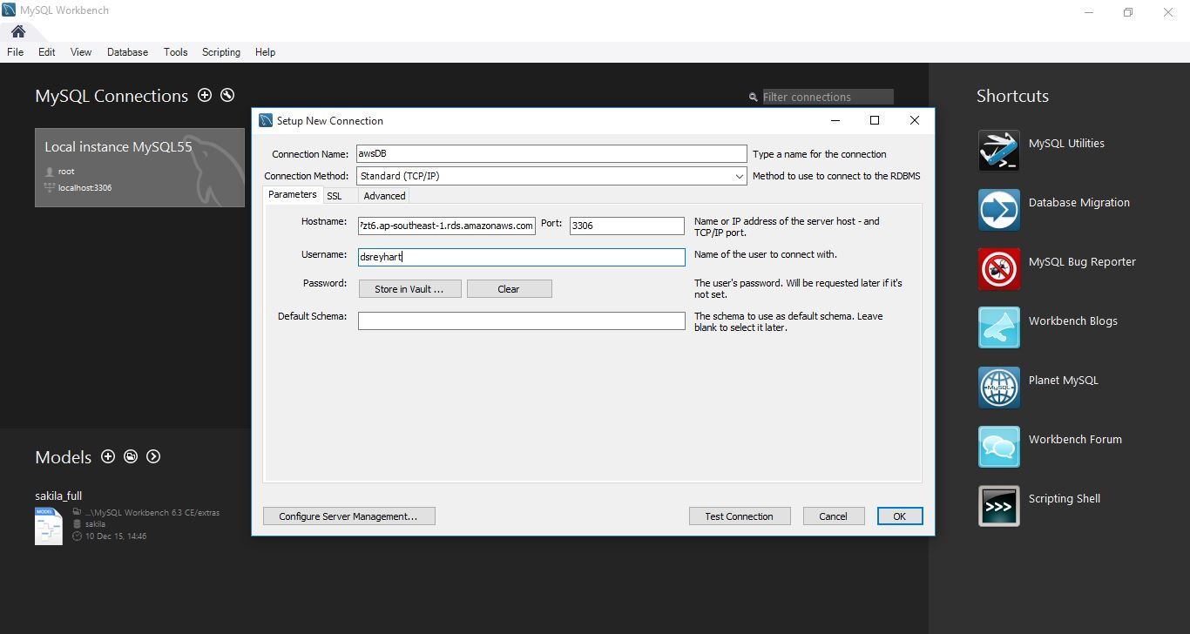

11.Insert password and press ok button.

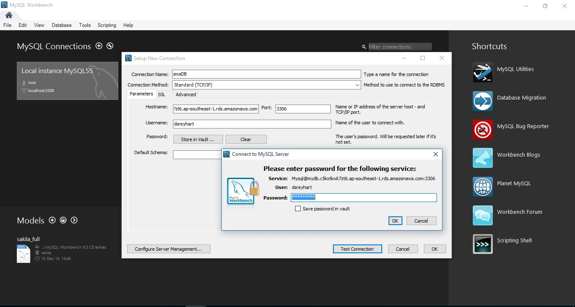

12. If everything is ok MySQL workbench will display a success message.

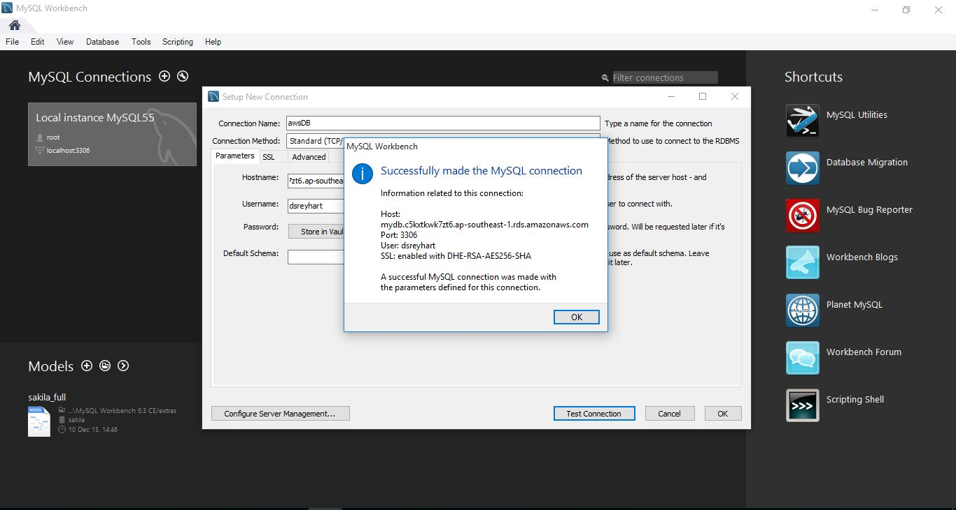

13. Connect using previously created connection.

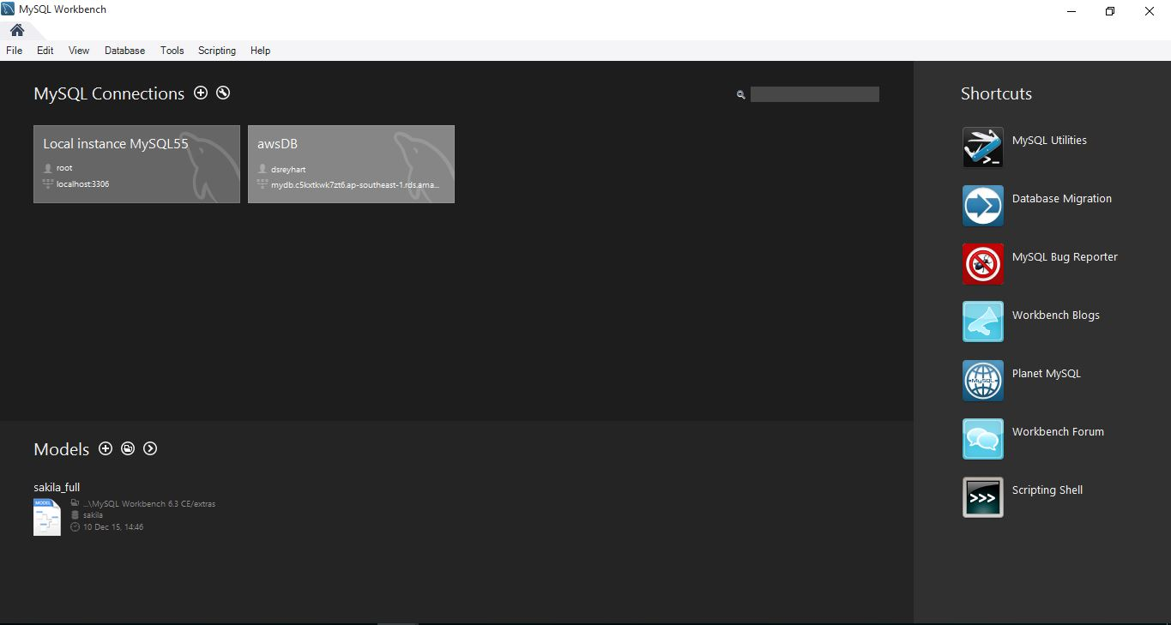

14. Connected to the AWS DB Instance. Now we can write queries on remote DB.

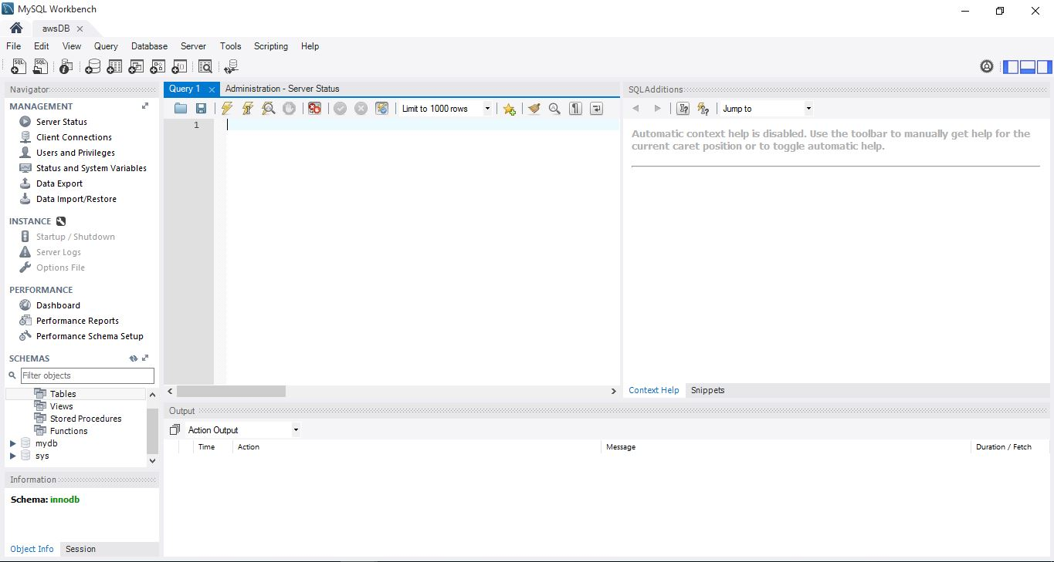

15. Deleting previously created DB instance.

